**SCHOOL PORTAL SECURITY WITH ACCESS CONTROL ALGORITHM FOR SENIOR HIGH AND COLLEGE IN WESTBRIDGE INSTITUTE OF TECHNOLOGY, INC.**

**MAIN BRANCH**

A Thesis Project Presented to the Faculty of the College Department

Westbridge Institute of Technology Inc.

In Partial Fulfillment of the Requirements for the Degree of

BACHELOR OF SCIENCE IN COMPUTER SCIENCE

by

ARNOLD C. OLAÑO

CESAR LENSTER LUNAS

JAMIL G. REGODON

**SY 2023 - 2024**

**Chapter 1**

**Chapter 1**

**Introduction**

**PROJECT CONTEXT**

    Utilizing technology effectively is essential to optimizing administrative procedures and guaranteeing a favorable experience for educators, administrators, and students in the dynamic realm of higher education. The proponent for Westbridge Institute of Technology Inc. (WITI) recognizes the need for comprehensive digital solutions and launches a project titled "School Portal Security   with Access Control Algorithm for Senior High and College."

       The student portal is an important online interface in today's educational environment that links students to important information within an institution of learning or colleges. Accessible via a secure login procedure requiring a distinct username and password, the student portal serves as the main means of contact between educational institutions and their students. In essence, the student portal serves as a central location where students may easily access and oversee several facets of their educational journey. This digital platform offers students an easy and organized way to keep informed and involved in their academic pursuits, while also improving the overall efficiency of administrative operations and improving communication.

     Westbridge Institute of Technology Inc. (WITI) provides a quality education in Cabuyao City, Laguna. The institution regularly observes an increase in enrollment, which can be attributed to its well-regarded reputation, affordable tuition, and dedication to offering a high standard of education that is integrated with modern technology. However, a notable absence within the institution is a comprehensive school portal accessible to students, registrars, teachers, and administrators, thereby hindering seamless integration across various systems. Recognizing the need for improvement, there is a proposal for the implementation of a School Portal Security  , featuring access control algorithms for both Senior High and College. This strategic initiative is anticipated to yield significant benefits for the institute, including time savings, conflict mitigation, and easy access to academic records for students. Furthermore, the proposed portal seeks to enhance overall efficiency, allowing stakeholders to dedicate their focus to academic pursuits, fostering an environment conducive to improved academic performance and outcomes.

**Purpose and Description.**

The goal of that research was to develop a system called “SCHOOL PORTAL SECURITY WITH ACCESS CONTROL ALGORITHM FOR SENIOR HIGH AND COLLEGE IN WESTBRIDGE INSTITUTE OF TECHNOLOGY INC. MAIN BRANCH” to ensure that only the right people could access important information and features. This helped keep student, teacher, and administrator data safe, prevented unauthorized entry, and ensured a secure learning environment by reducing the risk of data problems or misuse.

User interface for inputting and managing school portal security.

1. Gathering information of the student, teacher, registrar and admin will be done to input and manage school portal security effectively.
2. Algorithms are developed to  detect and prevent unauthorized access and use the ACA algorithm to give access to the specific user their needs
3. A database is used to maintain a record of the interactions and activities that users have within the portal.

**Objectives of the Study**

     The primary goal of this study is to provide the security of Westbridge Institute of Technology Inc's school portal through the implementation of access control algorithms for Senior High and College students. This security aims to protect sensitive information and ensure that only authorized individuals can access the portal.

More specifically, the study aims to achieve the following objectives:

1. Create and implement access control methods that are specifically suited to Westbridge Institute of Technology Inc.'s senior high and college students' demands.
2. Analyze how well the access control algorithms are able to shield sensitive data from unauthorized access.
3. Analyze how improved security measures affect system performance and user experience.
4. Effectively integrate the data of integrated softwares  mentioned.
5. Make suggestions for ongoing security measures and adaptation to new threats and technological developments.

**Scope and limitation** The scope of the study is focused on the development of a School Portal Security   with access control algorithm for Senior High and College in Westbridge Institute of Technology, Inc. The system aims to enhance the security of a school portal, and integrating it with enrollment, admission, and scheduling systems can address several common issues. These include unauthorized access to sensitive information, usage of weak passwords, inadequate data protection measures, lack of monitoring for potential attacks, unsafe data transmission between systems, improper management of user accounts, failure to verify the security status of users, and absence of a backup strategy. Resolving these issues is imperative for ensuring the security and integrity of the portal and its associated data

 In order to accomplish this, the study will collect information about the needs and preferences of the administrators and staff at Westbridge Institute of Technology, Inc. with regard to access control and school portal security. After that, a software solution that satisfies these needs will be designed and developed. The system will have an easy-to-use interface to improve the security of the school portal, access control algorithms to handle security issues, and a strong database to store and retrieve confidential data.

      Nonetheless, it's important to acknowledge the limitations of this study. Currently, the findings may not be directly applicable to other educational institutions, as the research is tailored specifically to address the requirements of Westbridge Institute of Technology Inc. Introducing a new system to  staff and administrators’ new procedures could pose challenges in terms of implementation and acceptance, potentially hindering the study's effectiveness.

**REVIEW OF RELATED LITERATURE AND STUDIES**

**TECHNICAL BACKGROUND**

       Westbridge Institute of Technology (WITI) currently lacks a school portal, which means that only administrative staff have access to sensitive documents and areas. However, implementing a School Portal Security with Access Control Algorithm for Senior High and College at WITI presents a challenge due to concerns about data security. By incorporating this algorithm, we can effectively address these security issues at WITI. The proposed system will significantly improve security measures, ensuring that only authorized individuals can access the portal once it's implemented. WITI's proactive approach to implementing this security   demonstrates our commitment to providing a safe and secure online environment for Senior High and College students once the portal is established.

**FOREIGN RELATED STUDIES**

     Skills and knowledge can be transferred by network-enabled computers called student portal. Since new technologies are commonly thought to make a big difference in education, many universities have adopted portal of student to support teaching and learning processes. Most portal applications allow for student to delivery and tracking of elearning courses, content, testing, and the management of instructor-led training classes Baheshm, Y. A., Aldhaibani, A. O., & AL-Shami, S. A. (2020). Online Student Portal.

It helps to generate a monthly oversight sheet. Manual attendance system requires countless paper work and calculations and there will be great chances of errors. To save the time of maintain lecture trade data and average attendance of each student Online College Portal system intent to improve the efficiency of college information management, and the main function is managing and maintaining information [2]

PCE(Priyadarshini College Of Engineering) The Staff / Student Portal is the commonly used phrase to describe the login page where students can provide a username and password to gain access to an scholastic organization’s programs and other learning related materials. For example, a beginner who has enrolled in an online certification program may use a student portal to ingress online course materials, such as articles, lectures and videos hosted on the college’s server. Staff/student portal is also used to provide information about the college, special events, course details, calendars, academic resources and contact material [3].  

Portals are gateways that provide users with the information they need from different sources and display it on a single page. It is important to see that universities utilize the resources and services provided by their student portals. With the rapid development of Information and Communication Technology (ICT), the Ministry of Education in Saudi Arabia aims to develop and improve student portals by providing high-quality teaching services through the university portal systems. [4]

There is discussion about usability of the student portal. Usability is a key factor that determines the success of a management software or interactive system, like a student academic portal. The increasing usage of a portal requires a usability evaluation method that is more accurate and effective to find usability problems, so it can be used for management service improvement in the academic process. [5]

It discusses the development of a web-based application for new student admissions at PAB 8 Saentis Private High School, which aims to replace the conventional, error-prone manual admission process with a more efficient and accurate computerized system. The application utilizes technologies like PHP and MySQL and follows the waterfall model for its development [6].

 Integrating an access control algorithm into a school portal can enhance data management, ensuring efficient, orderly, and secure handling of student admissions. This approach would not only simplify the process for administrators but also provide a more transparent and accessible system for parents and guardians, especially important in special education contexts where individual needs and sensitive information are paramount [7].

**Foreign  Related Literature**

Good time management is related to perceived control of time, job satisfaction, and health, while being negatively related to stress. However, its relationship with work and academic performance is unclear. Time management training improves skills but may not necessarily lead to better performance. The research has some limitations, such as varied definitions and methods, reliance on self-reports, and little consideration of job and organizational factors. The review provides insights for developing more effective time management practices. [8]

It offers time-saving tools for administrators, immediate access to grades for parents, and progress tracking for students. It allows teachers to manage grades, attendance, and communication. The system is web-based, requiring only an internet connection and desktops. It is platform-independent and customizable for each school's needs [9].

The system was developed using management information systems and database technology. The paper discusses the background and purpose of the project, followed by details about the development platform and database technology used. It focuses on analyzing requirements, designing and implementing the system, and using various tools and techniques. The end system simplifies tasks like inputting information, retrieving data, making changes, and generating  reports. The goal of the project is to create reliable software that helps administrators and users make accurate and timely decisions by effectively storing and processing information [10].

Based on the findings, it can be concluded that the existing constraints will continue to limit the effectiveness of personnel scheduling management systems in construction field offices. However, implementing the proposed system is expected to improve personnel scheduling management by standardizing procedures and reducing reactive management. The study suggests three approaches with varying degrees of effectiveness: a manual system, a spreadsheet system, and a network system. [11]

The move to using cloud-based technology in healthcare, like what Prince and Lovesum talked about in 2020, is similar to a change that needs to happen in schools, like Westbridge Institute of Technology. This change can help schools better organize their teaching materials and make it easier for high school and college students to access what they need for learning. [12]

Ms. Sakshi Nandu Kamod (2023) demonstrated, College management system is an integrated web application that handles various academic and nonacademic activities of a College/Academic Institute. The system can be accessed by every student/faculties/employees of the institution through internet connected computers or internet enabled mobile devices with the aid of his username and password. Every user will have a customized home page with his/her profile management facilities. Through links that display in the home page the user can access different options of the website assigned. Though the system allows access to every one there is a significant security risk involved in this project [13].

In present day world and not utilizing digitalization not a superior way, utilizing present day innovation and web for diminishing work and expanding proficiency is a way to computerized nation and utilizing innovation helps in having a keen work process so to execute this in school an Online School Portal is intended to execute digitalization and lessening work of school staff/personnel like figuring level of participation and imprints ,giving time-table, keeping records in documents for quite a long time is diminished by this framework furthermore, to conquer the issues caused by human mistake and wastage of time doing all procedure physically [14].

District leaders need to reassess the effectiveness of parent portals in supporting academic success. Based on a study focused on family engagement during the middle-to-high school transition, this article highlights challenges faced by both families and school leaders. It emphasizes the importance of systematically reflecting on the design and purpose of parent portals to ensure they effectively communicate information and serve as a useful tool for families in monitoring and improving students' academic progress [15].

The online academic portal serves as an information system in tertiary institutions, encompassing various academic details such as student activities, faculty, and administrative staff. Despite the existing online academic portal system in national universities, it lacks effectiveness in utilizing web-based services. To address this, researchers aimed to develop an Android-based national university academic portal system, facilitating user access without the need for the National University website. Through the waterfall method, a well-established system development approach, the researchers used PHP, PostgreSQL, and Android Studio for application design. The trial demonstrated 100% accuracy in displaying academic information [16].

IoT based cloud computing technology provides an intelligence system, unified campus portal services, security and maintenance system. The digitally connected campuses enhance student learning and environmental sustainability. Students can use smartphones, PDA to access their homework assignments and test performance through online portals. Video can be uploaded in the cloud, online video Lecturing enables Students to attend classroom lectures remotely. IoT devices are used to track students who Skip their classes, send alerts, help students to concentrate on academic work regularly, and to find lost personal items. Through Digital devices payments can be made easy at the cafeteria, office and in other admin activities [17].

College Portal provides a simple interface for maintenance of student–faculty information. It can be used by educational institutes or colleges to maintain the records of students easily. The creation and management of accurate, updated information regarding a students’ academic career is critically important in the university as well as colleges. Student information system can deal with all kind of student details, academic related reports, college details, course details, curriculum, batch details, placement details and other resource related details too [18].

The portal provides an online web-based solution for educational use. The landing page of this website shows the features like a login tab so that the student and staff can log in easily, making way for acquiring various information. With that, it provides features such as a photo gallery and details regarding the workshop attended, paper published. The unique feature of this portal is its way of connecting the students, and staff of that college [19].

Passive communication channels, such web-based parent portals that enable families to track their children's grades all year long, can also facilitate effective communication between schools and families, directing parental support for students [20].

A school portal system can serve as a hub for integrating international perspectives and resources into the curriculum. It can offer access to global educational content, facilitate communication with international educators and students, and provide platforms for collaborative international projects. Additionally, such a system can be instrumental in gathering feedback from all stakeholders (management, teachers, students, parents) on the effectiveness and perception of the internationalized curriculum, aiding in its continual improvement and adaptation. [21]

A school portal system in high-tuition Catholic schools in the Philippines can help by giving clear information about fees, offering details on financial help and scholarships, and providing resources about the school's Catholic teachings and social work. It's a way for students, parents, and teachers to stay connected, share feedback, and get involved in community projects, which helps make sure the school stays true to its mission of education and helping others. [22]

**Local Related Studies**

Sensitive educational data is becoming digital, which emphasizes the need for security in School Management Systems (SMS). The study conducted by Grepon et al. on e-School systems emphasizes operational elements, but it also subtly draws attention to the need for strong security measures in SMS, particularly in access control mechanisms. These algorithms are essential for preserving the integrity and security of student and teacher information, as well as protecting data from unwanted access [23]

Although the focus of the Aklan study was not explicitly on security, the development of a web-based system inherently includes considerations for secure access and data protection. For your thesis, this can be related to the necessity of implementing robust security measures, such as access control algorithms, to protect sensitive educational data [24].

IT emphasizes the importance of Information and Communication Technology (ICT) in education. This is closely related to the need for robust school portal security and efficient access control algorithms. By ensuring secure and controlled access to e-learning resources, the integrity and effectiveness of educational programs can be maintained [25].

A Web portal is also common for academic institutions, business solutions, government services, and entertainment applications. Initial activity in accessing web portals is logging in usernames and passwords. Prominent for these applications are implementation of hashing. This is done in every password to ensure additional layer of security in providing confidentiality for user passwords [26].

The Effectiveness of Information Systems in the Enrollment of State Universities and Colleges in Central Luzon Philippines" explores the impact of information systems on enrollment processes in Philippine universities. It emphasizes system and service quality, which are crucial for enhancing school portal security and access control algorithms. Better system quality ensures robust protection against unauthorized access, while service quality ensures these security

measures don't hinder user experience [27].

The paper by Alimboyong and Bucjan (2021) discusses cloud computing adoption in Philippine state universities and colleges, focusing on challenges like slow internet and limited cloud computing understanding. These insights are relevant for enhancing school portal security, emphasizing the need for robust security measures like advanced access control algorithms to protect educational data and ensure secure access, reflecting broader themes in technology adoption and security in education [28].

The effectiveness of admission profiles in predicting academic performance in a Philippine state-operated high school. It evaluates the relationship between admission test scores, pre-entry grades, and student performance. This research can inform school portal security emphasizing the importance of multifactorial evaluation for secure and efficient data management. [29]

The document "Building a Framework for the Integration of School Management Systems (BFISMS)" by Romeo E. Balcita and Thelma D. Palaoag focuses on enhancing school services through technology integration. It emphasizes the necessity for efficient services to students, guardians, and employees. The study is qualitative and descriptive, involving literature review, interviews, and analysis of existing school management systems. Key areas include biometrics for attendance and security, mobile teaching tools, and online services for information access. The integration of technologies in school management systems aims to extend operations, provide real-time information, and improve service quality, particularly in student services like enrollment, grading, library management, and tracking. [30]

The study "The Admission Policy Test and Effectiveness of Islamic Education in a Secular State" is relevant as it highlights the importance of regulated access and effective policy implementation in educational environments. This parallels the need for robust access control algorithms in school portals to ensure secure and authorized access, safeguarding educational materials and student data. [31]

Colleges and Universities have been established to provide educational services to the people. Like any other organization, the school has processes and procedures similar to business or industry that involve admissions, processing of data, and generation of reports. Those processes are made possible through a centralized system in storing, processing, and retrieval of data and information; the majority of the schools in the country are already adopting computer-based systems to address their needs, especially on their student and school-related transactions. [32]

The Western Visayas College of Science and Technology (WVCST) Grades and Account Inquiry System was developed by their MIS Department to cater students' inquiry on grades, accounts, and latest information about the school. The system can be accessed on the designated area installed, it uses touch screen technology where students will have to enter their id number in order to access the information. The system is installed locally within the school campus only. [33]

In the past years, the Philippine Education System still used manual processes during enrollment procedures, not until the pandemic. The process and the start of the academic year didn't go well. Academic institutions are thinking of ways to get through this process. It may not be a big problem in other private schools; however, it has been a major problem in public schools. In this study, we developed a web-based Enrollment System for Public Junior High School in the Philippines tested in one of the most populous public junior high schools in the province of Cavite. Results show that the requirements set by the user were met. The overall evaluation shows that the system is effective and useful in addressing what the school needs. [34]

The purpose of the study is to design and implement an enrolment system through web based application intended for higher education institutions in Zamboanga Peninsula amidst covid-19 pandemic. The functionalities of the system are guided using Use Cases identified during the requirement phase. The existing system encountered several constraints on the process of the enrolment, especially in detecting conflict of course schedules and the availability of slots of the courses offered, handling large amounts of data, and in cases where modifications or errors in the program need to be fixed. The methodology used was prototyping to take advantage of the limited experience of users in using computerized systems. It was implemented using Hypertext Pre-processor (PHP) programming language and MYSQL database along with JavaScript, Cascading Style Sheets (CSS), JQuery and Macromedia Dreamweaver as integrated development environment (IDE). The functionalities of the system get the approval of the school administrators allowing the program to be use in an actual enrolment setting. [35]

.

The aims of this research are to evaluate the efficiency of the Davao del Sur State College Online Enrollment System. Students were chosen at random to complete a questionnaire about the efficiency of the system in question. This research also aims to determine what methodological instruments can be used in assessing the respondent's assessments. It will also identify the areas that need to be changed. This research also aims to determine what methodological instruments can be used in assessing the respondent's assessments. It will also identify the areas that need to be changed. As a research design, the researcher used the descriptive approach. [36]

The Computerized Enrollment System is designed to efficiently store and retrieve student information, offering a faster and more convenient alternative for faculty staff. This system aids in managing the increasing number of student enrollees, providing quick access to information, especially for transferees or those at a distance. The implementation of technology in enrollment processes helps reduce errors, processing time, and manual efforts. Inspired by online registration services, the researchers developed an online enrollment system for TNHS ANNEX, addressing challenges such as long lines and inaccuracies in manual systems. The proposed system aims to enhance efficiency, benefiting schools, teachers, students, and administrators by streamlining enrollment procedures and providing easy access to accurate information. [37]

This study was developed to create an electronic attendance and logging system using Radio Frequency Identification (RFID) and Short Messaging Service (SMS) with a Web-based management system portal that allows users to access real time data to ensure campus security and smart information management. The students will use the RFID card system to check in and out of the main entrance, to both track attendance and log time and prevent unauthorized entrance therefore utilize the RFID technology. The LPU-LAGUNA SEALS system developed in this study has six main functions: to use the student RFID chip in the ID’s as gate pass,  to send daily SMS to parents about the student entry and exit time record,  to efficiently manage and monitor student attendance and logs thru intranet and internet,  to integrate Web-based system portal to access real time logs and attendance,  to provide printed reports and electronic files of attendance and logs, and implement the system in Lyceum of the Philippines – Laguna. [38]

A Web Portal is a website or service that offers a broad array of resources and online services, such as search engines, directories, news, e-mail, and online information. Portals have evolved to provide a customized gateway to Web information. This study aimed to develop an Online Research Portal. Specifically, it aimed to create an online repository of researches and articles, publish researches and articles online, manage web content, distribute content depending on the user privileges and access level, create a venue for collaboration with other research institutions, create linkages with other research institutions, access information while off-campus, and disseminate latest update on research. [39]

In this system, there are three types of users with different access levels. The Super Admin manages the entire system, setting defaults and handling all student records. They can enroll students, add rooms, subjects, and manage assessments. The Staff, such as the Parents and Admin Assistant, have limited access. They handle tasks like generating grade reports, student IDs, and managing scholarships. Instructors, the third type of user, have the most restricted access, mainly uploading grades to the system. Each role is tailored to specific responsibilities within the educational setting.. [40]

This study aimed to develop a web-based application called Research Portal which consists of research articles as quick references and up-to-date information about the university researcher. This software has evolved as a comprehensive record management system to track status of ongoing research commitments. Additional features were the notification and real-time collaboration tool which builds a key element of visibility in all aspects of information. [41]

"Integrated educational management tool for Adamson University," academic institutions like colleges and universities can use the system to easily maintain staff and student records.Using an information and publication system for schools that is web-based can also save schools money, time, and effort. The development of an online portal system will be feasible for an institution with a well-designed website. [42]

**CHAPTER 3**

**METHODOLOGY**

In order to develop the “**School Portal Security with Access Control Algorithm for Senior High and College in Westbridge Institute of Technology , Inc, Main Branch**”. The proponents will  follow a method to perform all the processes under an iterative waterfall. This chapter outlines the activities that were carried out by the proponents.

**Fig 1.0: Iterative Waterfall Model**

Requirement Specification, System Design and Software Design, Implementation and Unit Testing, Integration and system testing and Operation and Maintenance are the five key stages that flow from one to the next and are crucial to developers. The proponents of this study will employ the use of Iterative Waterfall Model of the System Development Life Cycle to be able to smoothly develop our proposed system. The five steps of SDLC are intended to build on one another by putting up further Effort, utilizing the output from earlier stages, and producing outcomes that make use of earlier work and can be linked back to earlier stages.

The proponents will see the benefits of using iterative Waterfall which makes it possible for better structure and control. A product can advance easily and be delivered on time by setting up a plan with deadlines for each stage of the development process, such as concept, design, implementation, testing, installation, and troubleshooting. This strategy offers an easy plan for the project's progress and helps guarantee that each phase is finished before moving on to the next.

**The Requirement Specification**.

In the step of requirement specification, the proponents will assess how the system functions and determine the needs and requirements of the users. To understand the system's needs, the proponents will communicate with school administrators, parents, and the finance department. After gathering data and conducting research, the proponents will gather data, define the work plan, and will finalize the project plan.

During the System and Software Design phase, the system will be designed according to the specified requirements.This involves designing tables, preparing the project presentation, and evaluating the functionality and design of the system. The  proponents will review and update the system's tables and forms, will test all the features, and will create a data flow diagram (DFD) to illustrate the system's data flow. Additionally, an entity relationship diagram (ERD) will be created to represent the system's data model.Provide Flowchart of how the system works. Finally, the proponents will provide the necessary source code to build the system.

In the Implementation and Unit Testing phase, the proponents will carefully examine the system or application to ensure it fulfills the client's needs and detects any issues. The proponents will evaluate whether the software's features and functions are aligned with the specified requirements. This stage will focus on ensuring that the system will operate smoothly and reliably within the current operating environment.

In the Integration and System Testing phase, the proponents will train the users and test it out. The users will then check if the suggested features and functionalities have been properly implemented.

In the Operation and Maintenance phase, the main goal will be, to ensure that the information system is fully functional and runs efficiently. This phase will involve managing system updates, monitoring performance, and providing ongoing support to users. It will include essential tasks like data backups and creating user documentation. Deployment of the system on live systems occurs, followed by populating initial data and providing user training.

**Requirement Analysis**

The current system of the Westbridge Institute of Technology Inc. involves manual processes for teacher registration, student applications, and other tasks. However, the proponents will be active in exploring the implementation of a school portal to enhance and streamline the entire school transaction.

**Business Activity**

* **User Authentication and Authorization:**
  + Secure login for students, teachers,registrar, and administrators.
  + User roles with different levels of access (e.g., student, teacher, registrar, admin).
* **User Profiles:**
  + Ability for users to create and manage their profiles.
  + Update personal information, contact details, and preferences.
* **Dashboard:**
  + Personalized dashboards for each user role.
  + Quick access to relevant information such as schedules, grades, and announcements.
* **Class Schedules:**
  + Display of class schedules for students and teachers.
  + Ability to make changes to schedules when necessary.
* **Enrollment System Integration**
  + In this section, students can check their enrollment information and use the portal to make any necessary changes.
* **Admission System Integration**
  + This area is Administrators can monitor and manage the entire admission workflow efficiently.
  + It will detects if the student has a balance in previous semester and restrict student to login if they have balance
* **Scheduling System Integration**
  + Integrating with the scheduling system will allow students to view their class schedules, room assignments, and any changes in real-time.
* **Queueing System integration**
  + Enabling students to monitor their status for their request. Releasing of official document and requirements to request a specific document

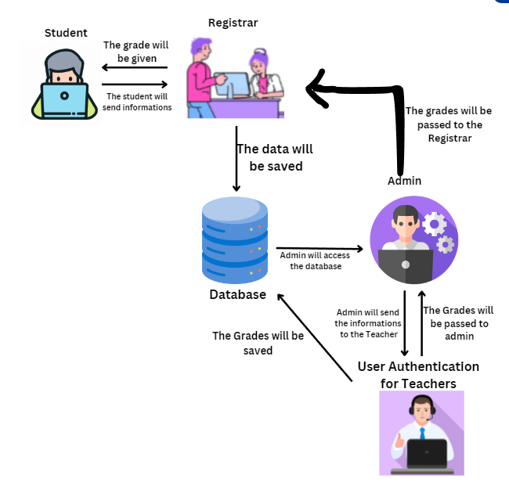  
 The Westbridge School Portal will serve as a centralized online platform for students, teachers, parents, and administrators, offering a range of features to enhance communication and accessibility. Users can log in to update personal details, check schedules, and monitor academic performances through online grades and progress reports. The portal will serve as a hub for school news and notifications, enabling administrators or teachers to promptly inform parents if a student misses class. Additionally, it will simplify the class registration process, making it easier for students to sign up for classes and facilitating a seamless experience for new students as they settle into the school.

**Requirement Documentation**

The proposed system, titled "**School Portal Security with Access Control Algorithm for Senior High and College**" at Westbridge Institute of Technology, Inc., was a web-based application intended to enhance the user experience and adapt to changes.

The portal included tools for updating personal information, viewing timetables, tracking requested document status, accessing school information, and facilitating effective communication among students, teachers, and administration.

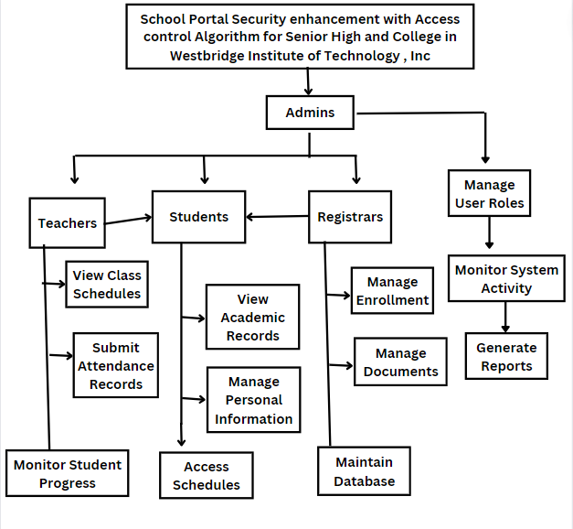

Figure 2.0 Decomposition Chart of the School Portal Security System

**Design of  Software, System, Products And/Or Process**

The proponents will construct a design for the system to be developed after collecting data, determining user needs through observation and interviewing users, as well as soliciting user comments.

The development of the "School Portal Security with Access Control Algorithm for Senior High and College" at Westbridge Institute of Technology, Inc," is successfully prepared using all the requirements from the first phase

Meeting the following standards, objectives, and goals will be necessary for

the design and development of software to be completed:

1. To avoid data breach and enhance security of the system

2. To manage and track the admission and enrollment process for new students.

3. To facilitate the creation and management of class schedules.

4. To improve communication between students, teachers, and administrators

5. To gather insights and generate reports on various aspects of the school's performance.

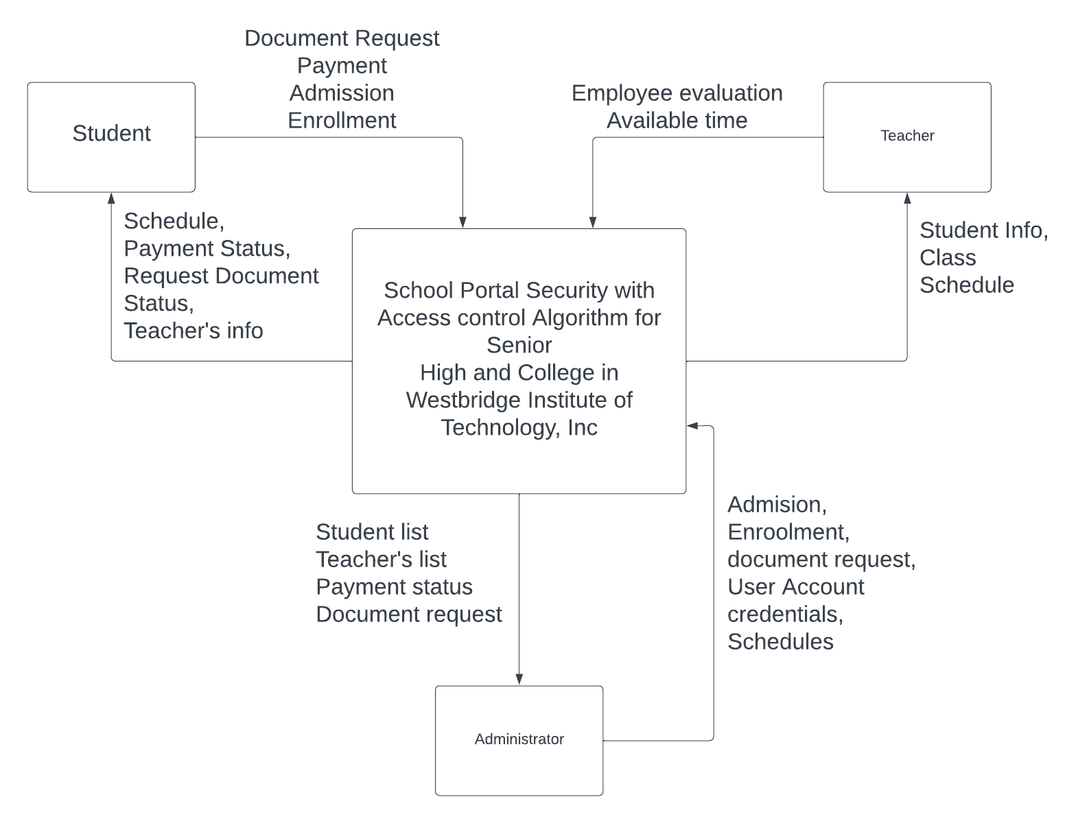

**Figure 3.0 Context Diagram of the proposed School Portal Security with Access control Algorithm for Westbridge Institute of Technology , Inc.**

The administrator input into the system that the parent, student and teacher gave them are depicted in the context diagram in Figure 3.0 above. The admin, teacher and student are the users who are being targeted. Portal Security is the anticipated output of the proposed system.

**Development And Testing**

The researcher will use a method called the Iterative Waterfall Model to build the system. It means the researcher will work through different stages step by step, like following a sequence.

During testing, the researcher will thoroughly examine the technology to see how well it performs. This includes conducting both initial and extensive tests on the new software. To ensure the system works as intended, the proponents will evaluate the new software, along with the hardware and software, before delivering it to the client.

**Software Requirements**

·   Visual studio code

·   Composer

·   Git

·   Github

·   Mysql database

·       Xampp

This software will be used by the proponents to create the School Portal Security with Access control algorithm for Westbridge Institute of technology, Inc to database, local server, design, and web forms and storage of records.

**Hardware Requirements**

·       Intel Quad Core or Higher Processor

·       4 GB Memory (Recommended)

·       80 GB, Hard Disk

·       Standard Keyboard

·       Standard Mouse

·       AVR/UPS

·       Switch

·       Monitor

·       Printer

**IMPLEMENTATION PLAN**

The system will be launched and used in a real production setting. This happens after the users have tested and approved it. The developers want to add a "School Portal Security with Access control Algorithm" to the school system. They will teach the users how to use it and run a trial. If the system includes the requested features and meets the users' needs, they will check it and give feedback. This will continue until the system meets all the user requirements and works properly.

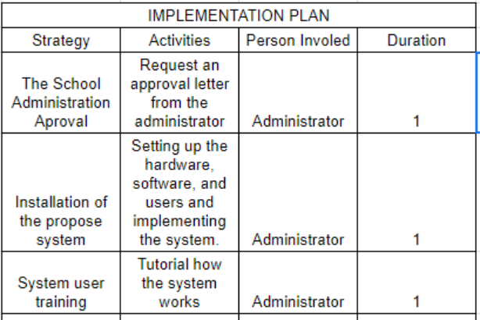

**CHAPTER IV  
SOFTWARE PRODUCT DEVELOPMENT**

**System Overview**

Westbridge Institute of Technology, Inc. (WITI) recognizes the importance of maintaining an efficient,  effective and secured school portal system that will protect basic data and information.

 School Portal Security with Access Control Algorithm (SPS-ACA) is a web based portal  that  can  be  accessed on a computer connected to a network. This system focuses only for filtering information, modifying basic data and limiting the functionality of an ideal school management system or school portal for a specific user.

SPS-ACA is a portal that will create an account for students and teachers where they can visit and check anytime. The teacher will upload the grades on the website. Because grades are available online, it will save time and be easy for students to see  and check their grades.

SPS-ACA will intend to protect private data and manage user's access to the institute's online resources. When someone tries to enter the school portal, the system will apply the access control algorithm to confirm his identity. Only authorized users using valid credentials can use the site, as it verifies several factors including passwords. This reduces the chance of illegal access and data loss. Additionally, the Access Control Algorithm will give the users different privileges according to their positions in the institution. As a result, there is less chance of data access or manipulation because each worker will only have access to the resources necessary for their job description.

The administrator will manage the SPS-ACA to ensure the security and integrity of the system. He will have access to the features of the teacher such as modifying grades, viewing class schedule and student information. His responsibility is to manage and obtain access to every student's data.

The researchers will develop features that can integrate other systems such as enrollment, scheduling and other future system projects. With the use of the Access Control Algorithm, it will help the system to prevent any harm and to protect the data of every Westinian student.

**System Architecture**

Important features like the scheduling and enrollment processes will be available via the school portal. Different features are available according to how the user will use it. Features like scheduling, document management, and enrollment management will be available to administrators. The students will be subject to certain limitations. Students will mainly use the access to schedule, registration processes, and document requests features. On the other hand, teachers may view their daily schedules and school activities aside from having access to the master list of students.

The user interface layer of the school portal system will allow teachers, students, and administrators a simple-to-use interface in which they will have access to a range of services including scheduling and enrollment. The system's main component is the application server that will collaborate with the school's student information system (SIS) to effectively handle the scheduling and enrolling procedures. Additionally, it will control the queue by assigning students a slot number based on priority or first-come first-served basis then they will receive notification when it is their turn. This is to ensure that only authorized users will have access to certain features like authentication.

The database server will make it possible to safely store important data such as enrollment records and course schedules. It will manipulate and retrieve the data efficiently. It will also provide strict security measures such as intrusion detection systems that will serve as protection  against threats and unauthorized access.

**ADMIN VIEW**

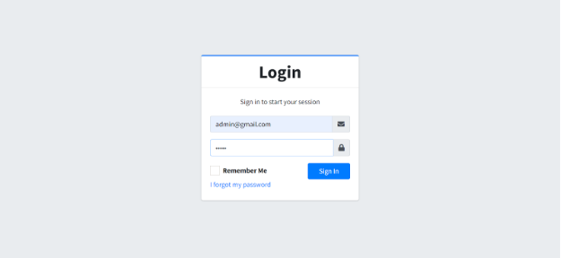

**Figure 4.1 Login form**

Figure 4.1 shows the administrator’s view when logging in the website using password.

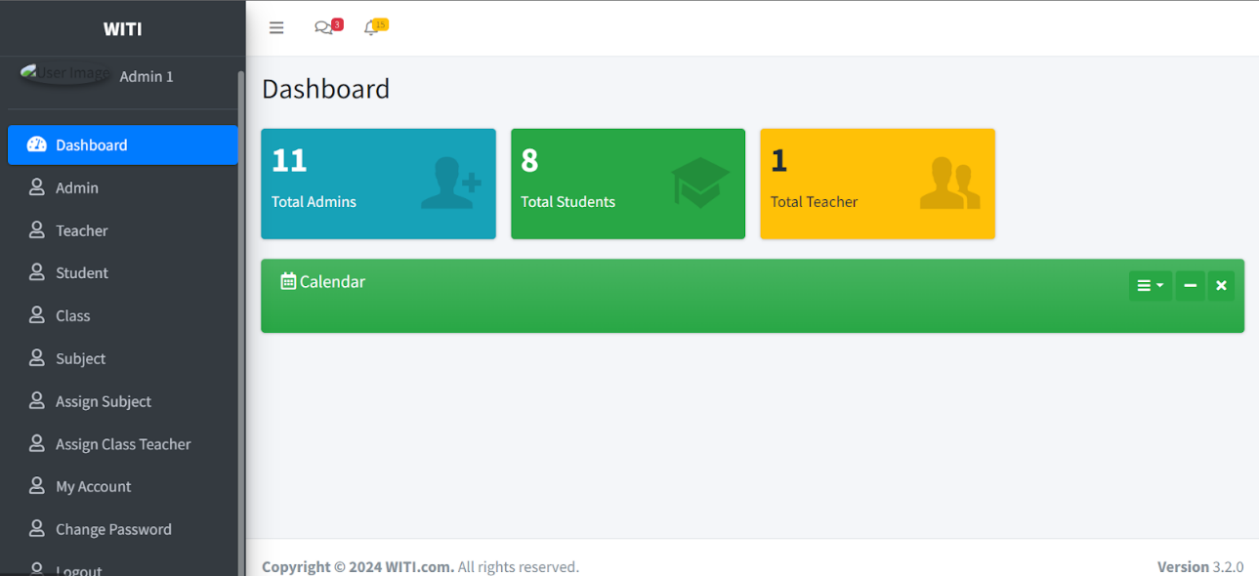

**Figure 4.2 Dashboard**

Figure 4.2 shows the dashboard page that will provide a summary of all user activity in the portal.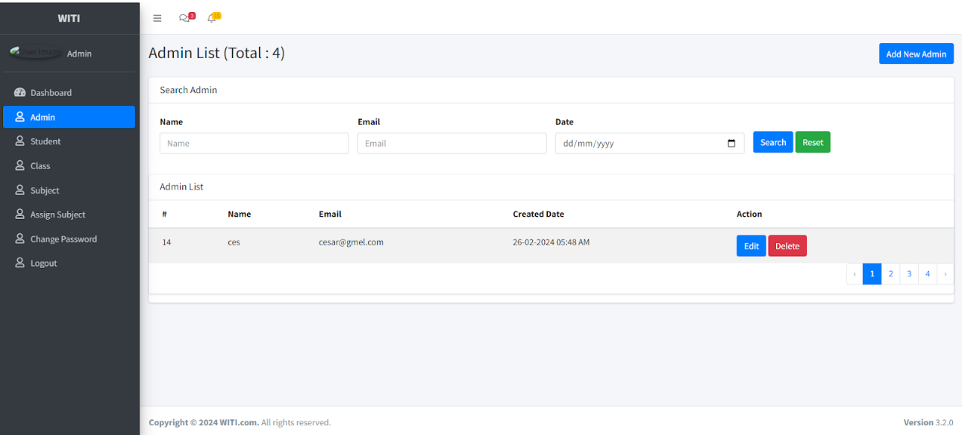

**Figure 4.3 Admin**

Figure 4.3 shows the administrator’s page that will allow other administrators to create accounts and use the portal's functions.

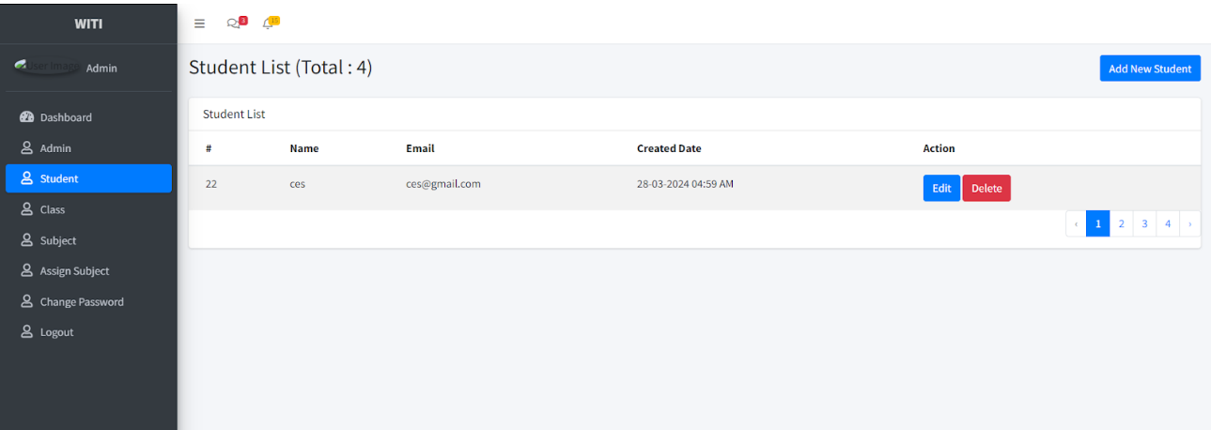

**Figure 4.4  Student Account**

Figure 4.4  shows the student account  in the view of the administrator.

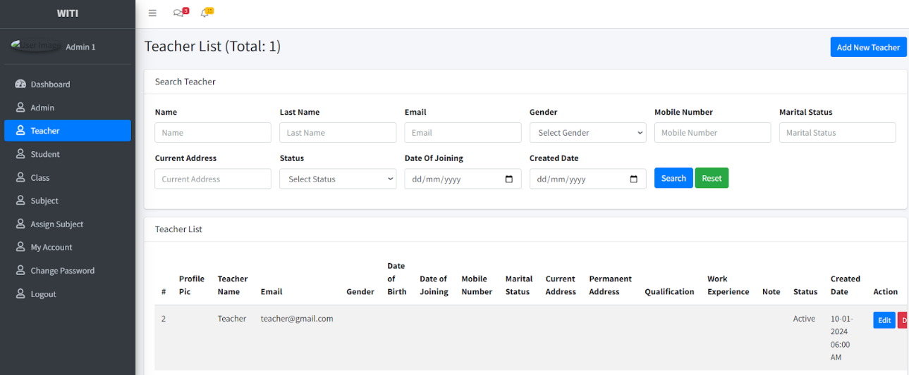

**Figure 4.5 Teacher Account**

The Teacher  page in figure 4.5  the admin can manage the account of Teacher  and create accounts for them.

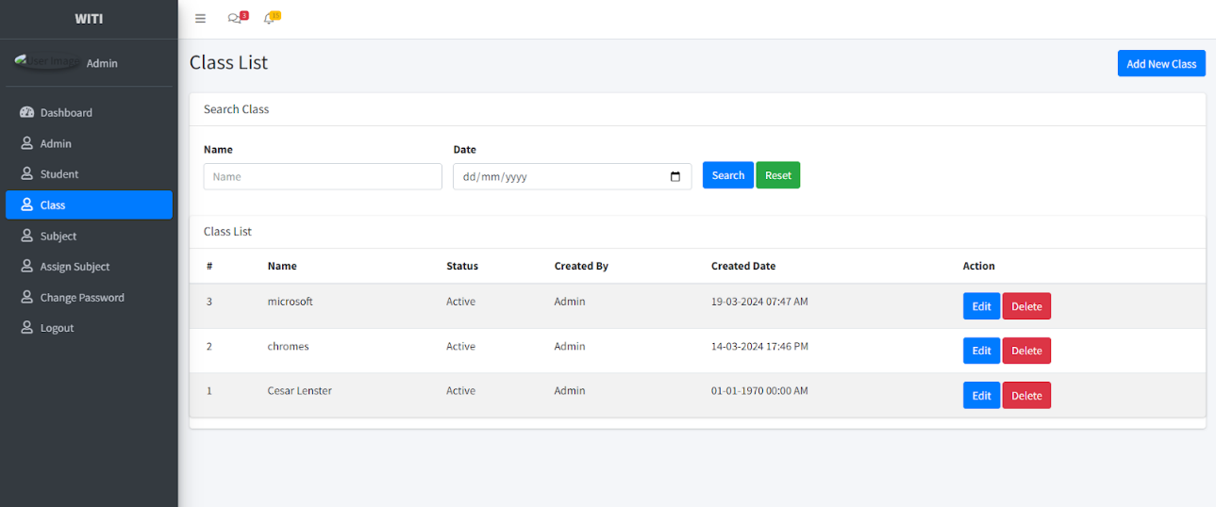

**Figure 4.6 Class List**

Figure 4.6 shows the Class list

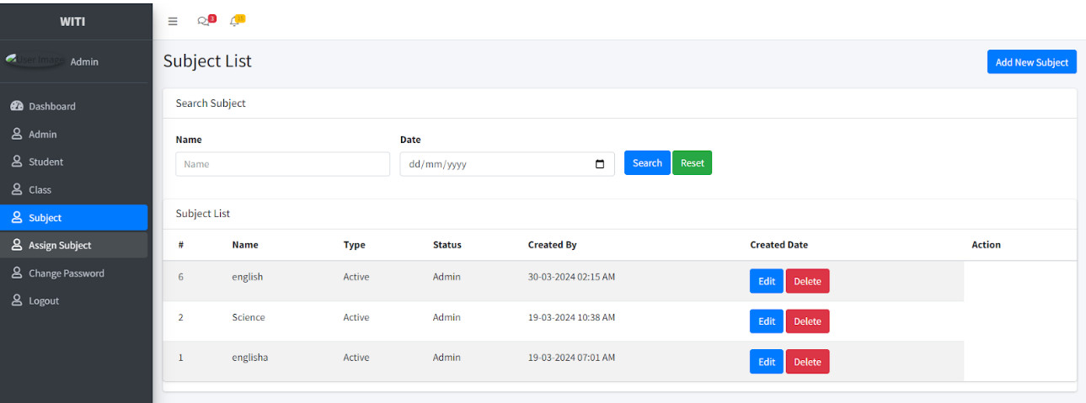

**Figure 4.7 Subject List**

Figure 4.7 shows the subject list allowing the administrator to add subjects for the teacher.

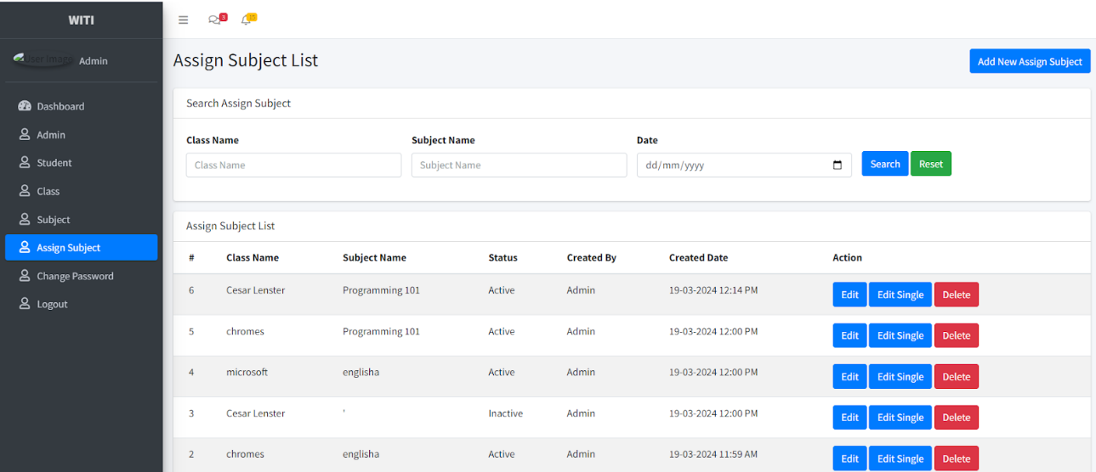

**Figure 4.8 Assign Subjects**

Figure 4.8 shows the assign subject  page allowing the administrator to assign the subject for the teachers.

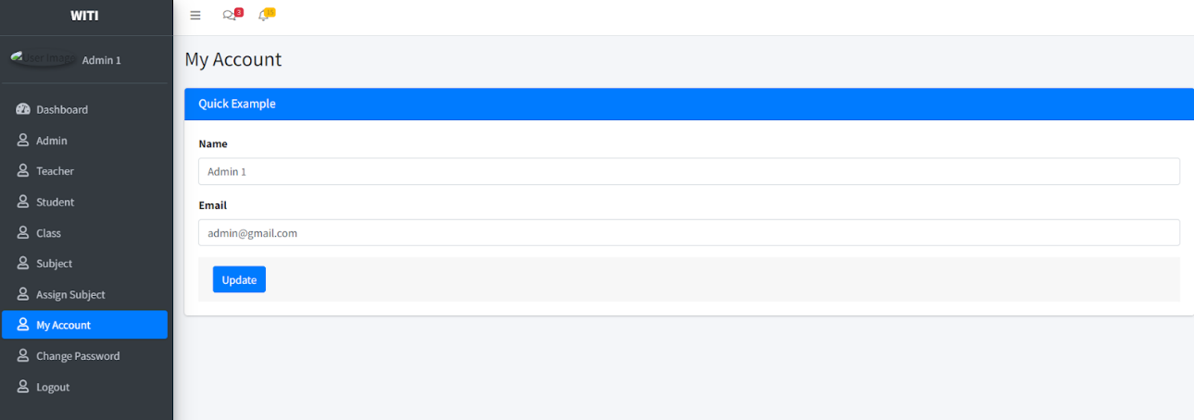

**Figure 4.9 My Account**

Figure 4.9 shows the account of the user where one can change name.

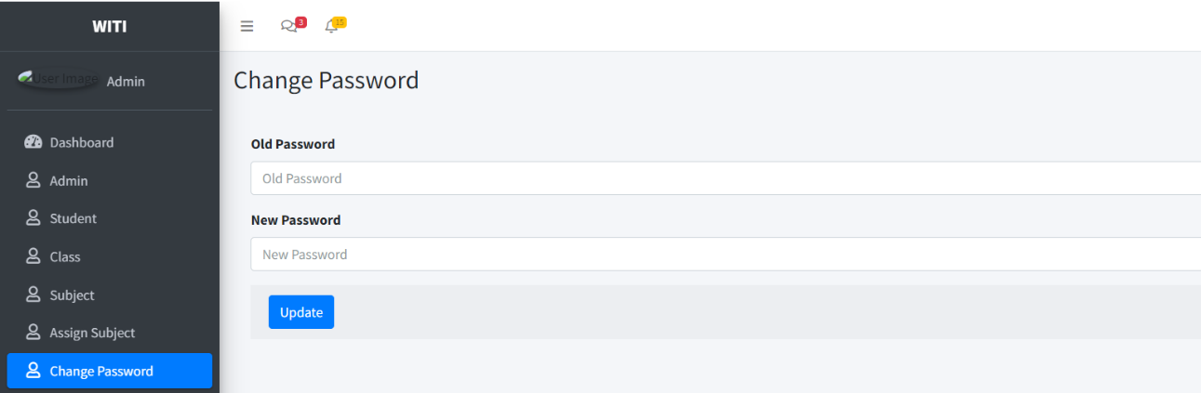

**Figure 4.10 Change Password**

Figure 4.10 shows the change password page allowing all the users to change password anytime.

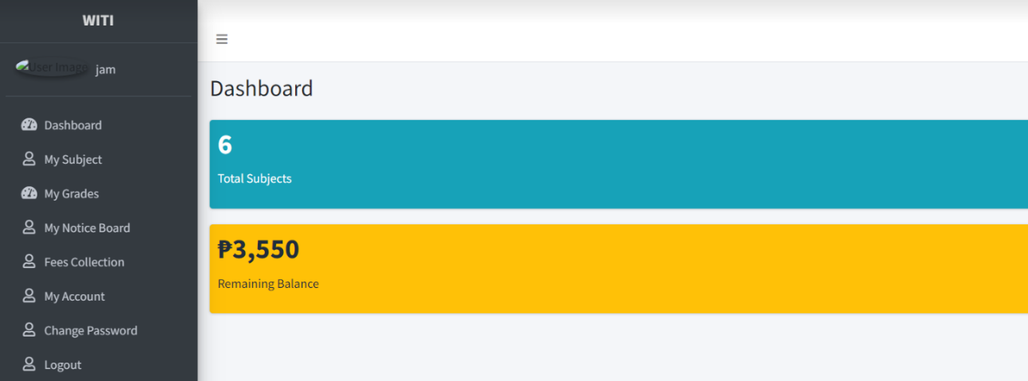

**Figure 4.11 Student Dashboard**

Figure 4.11 shows the student’s dashboard and its features when the user logs in as student.

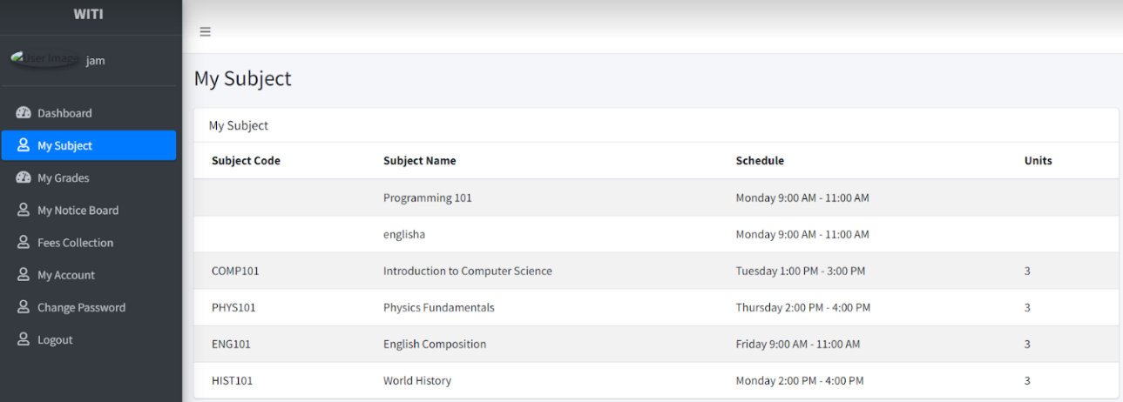

**Figure 4.12 Student’s Subject**

Figure 4.12 shows what are the subject code, subject name, schedule and the units for the student.

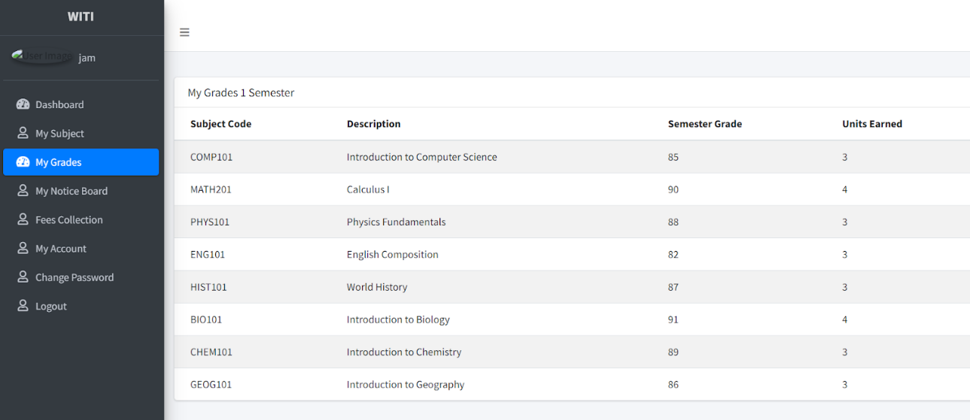

**Figure 4.13 Grades**

Figure 4.13 shows what are the grades of the student in that semester in every subject that student takes.

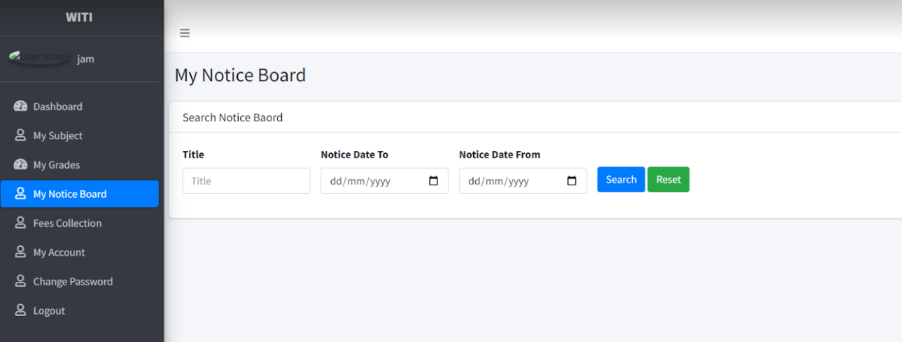

**Figure 4.14 Notice Board**

Figure 4.14 shows announcements to every student from admin

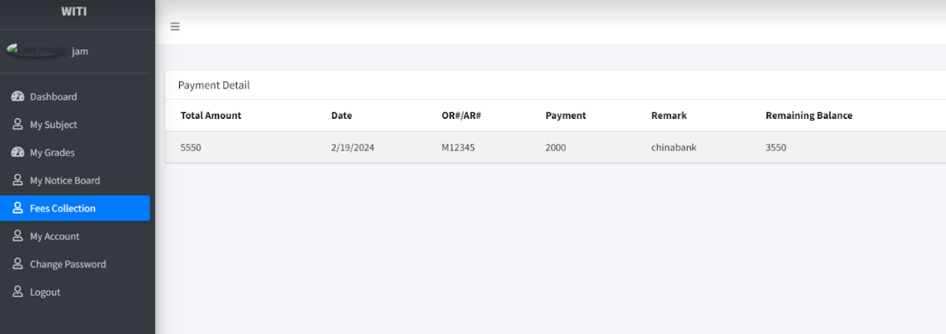

**Figure 4.15 Fees Collection**

Figure 4.15 shows what are the total amount and remaining balance of the student.

**1.0 Current Enrollment Workflow**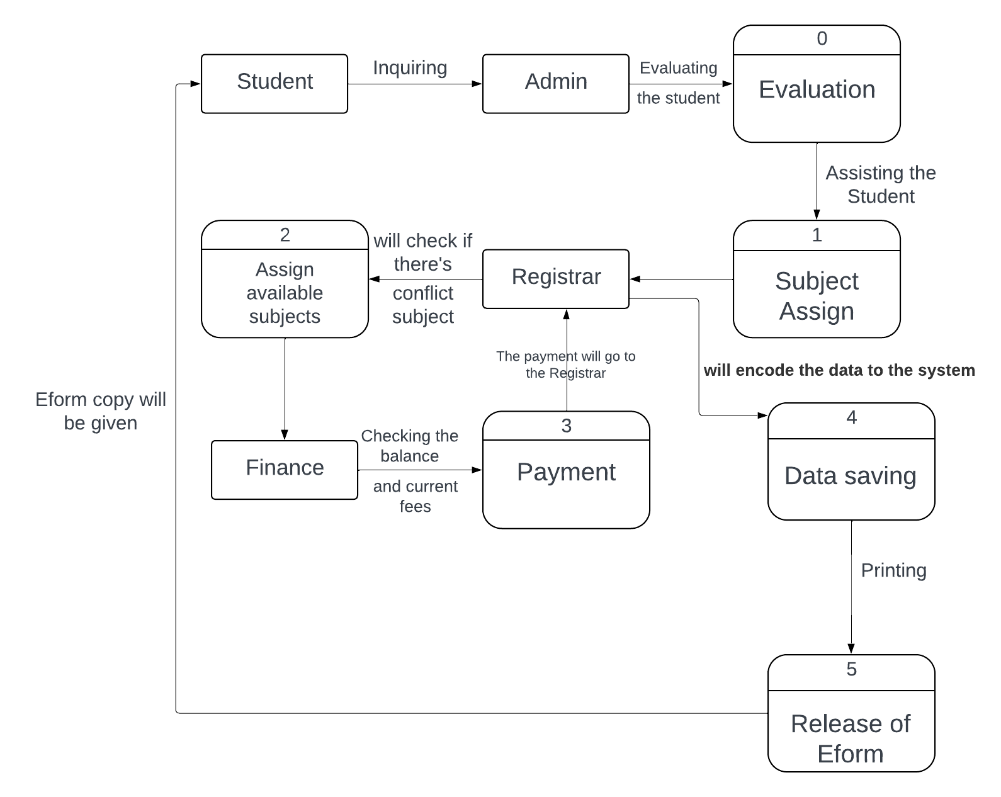

**2.0 Proposed Data Flow Diagram**

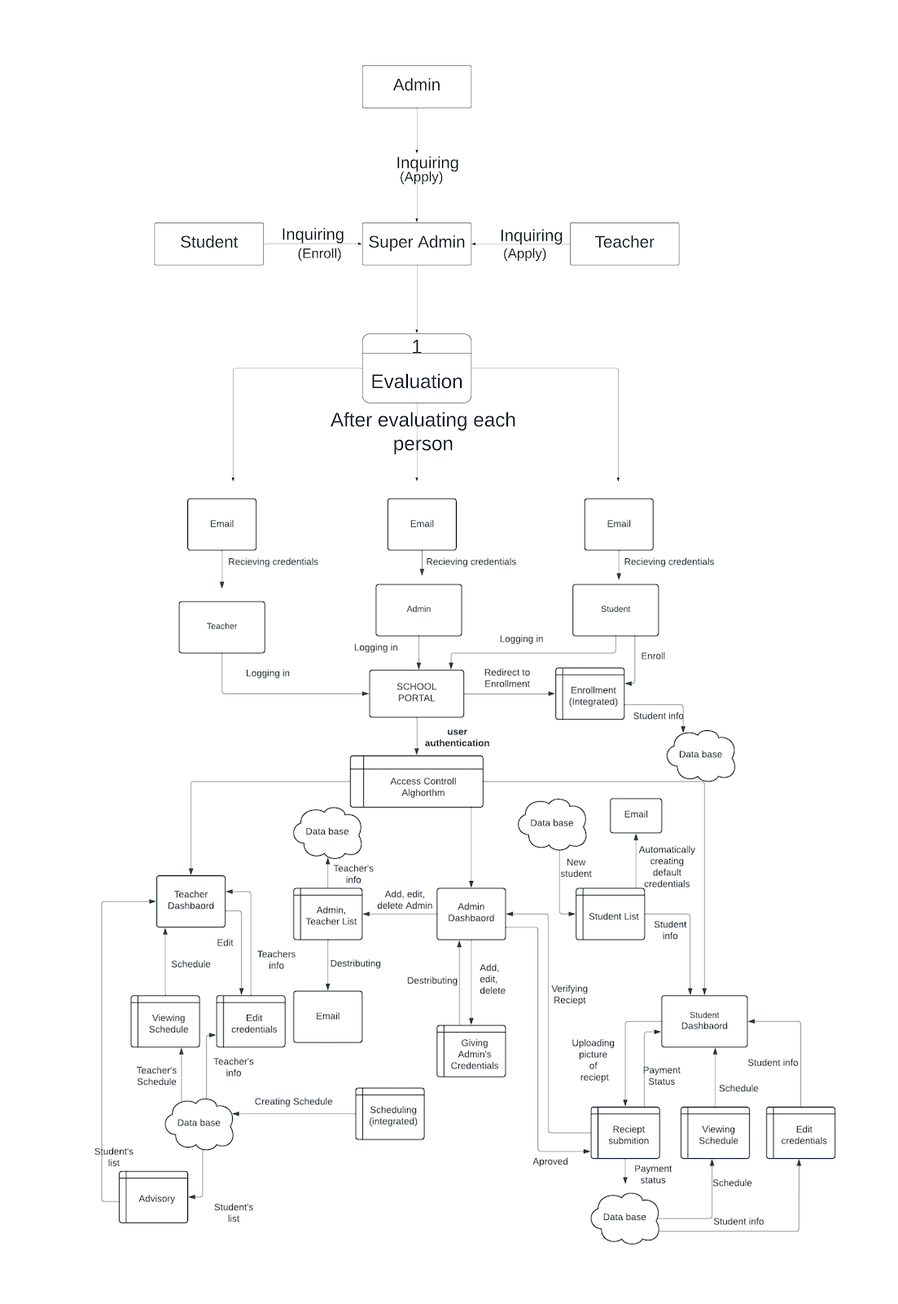

**System Flowchart**

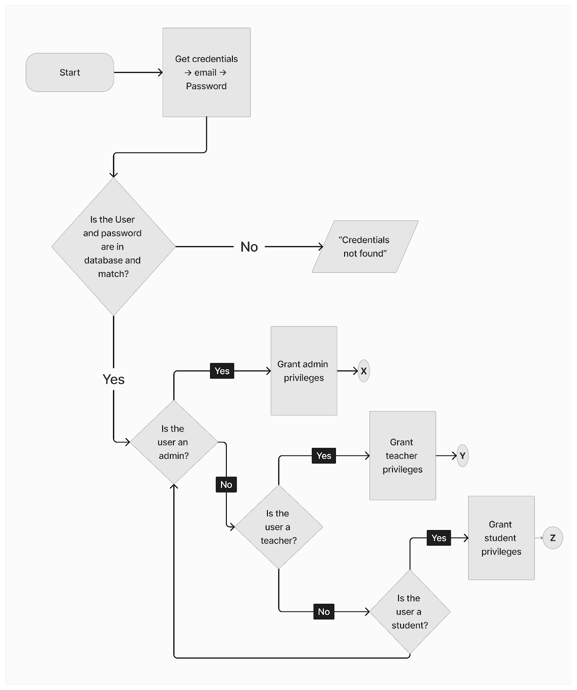

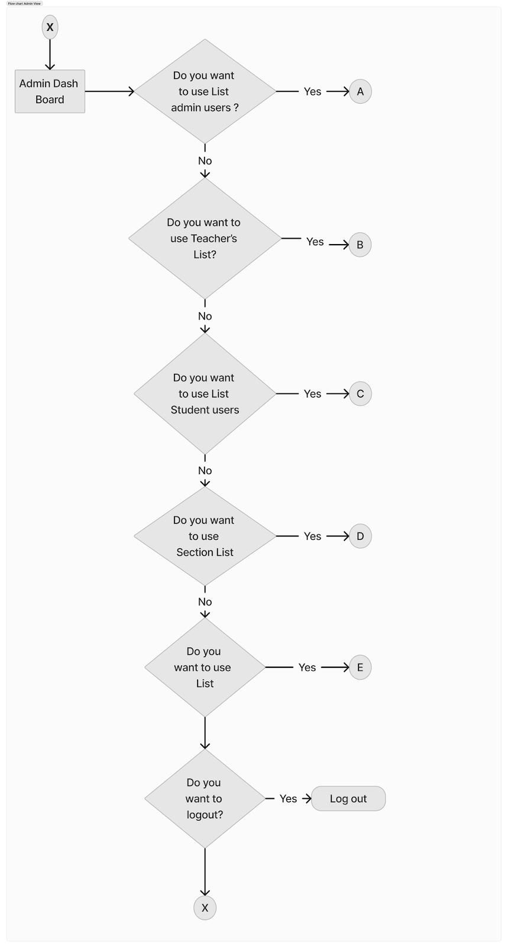

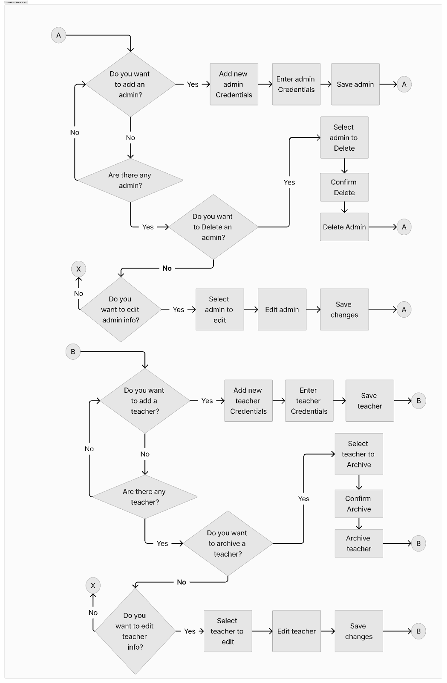



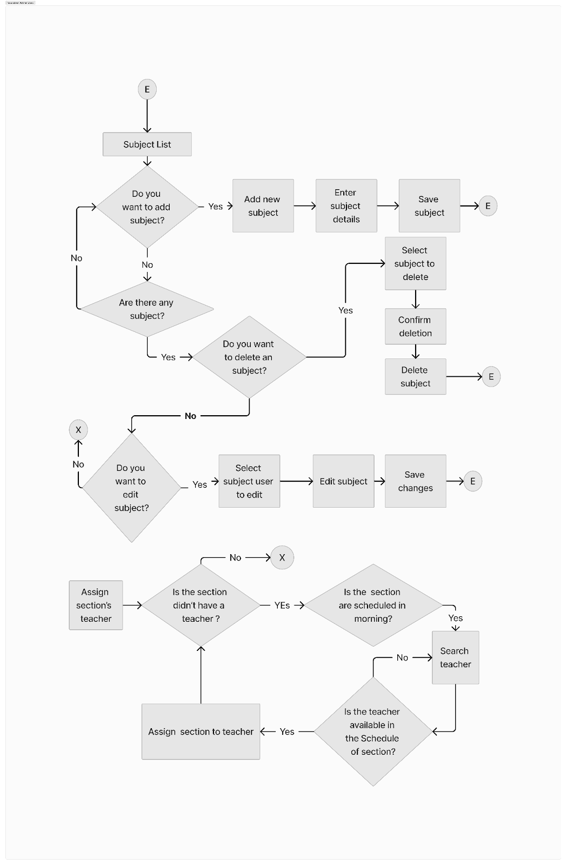

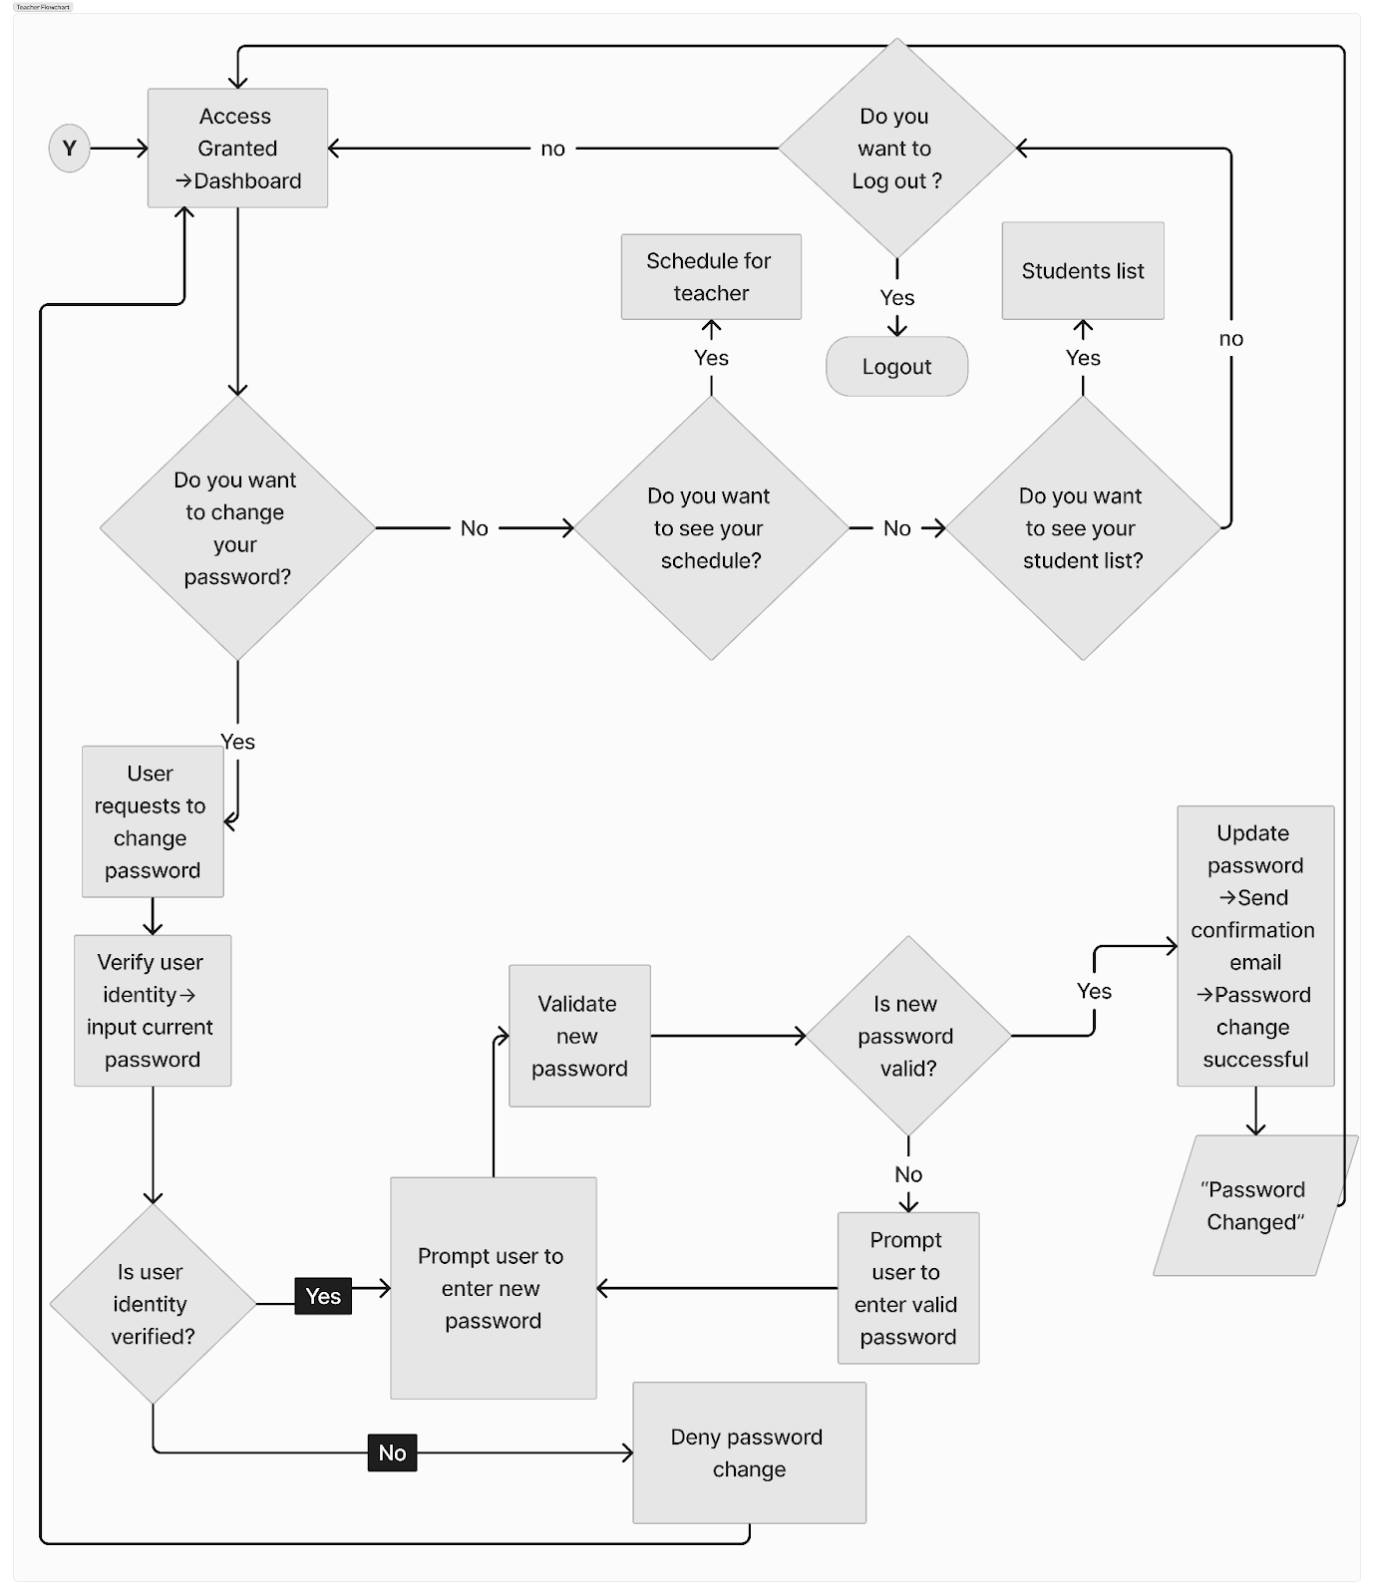

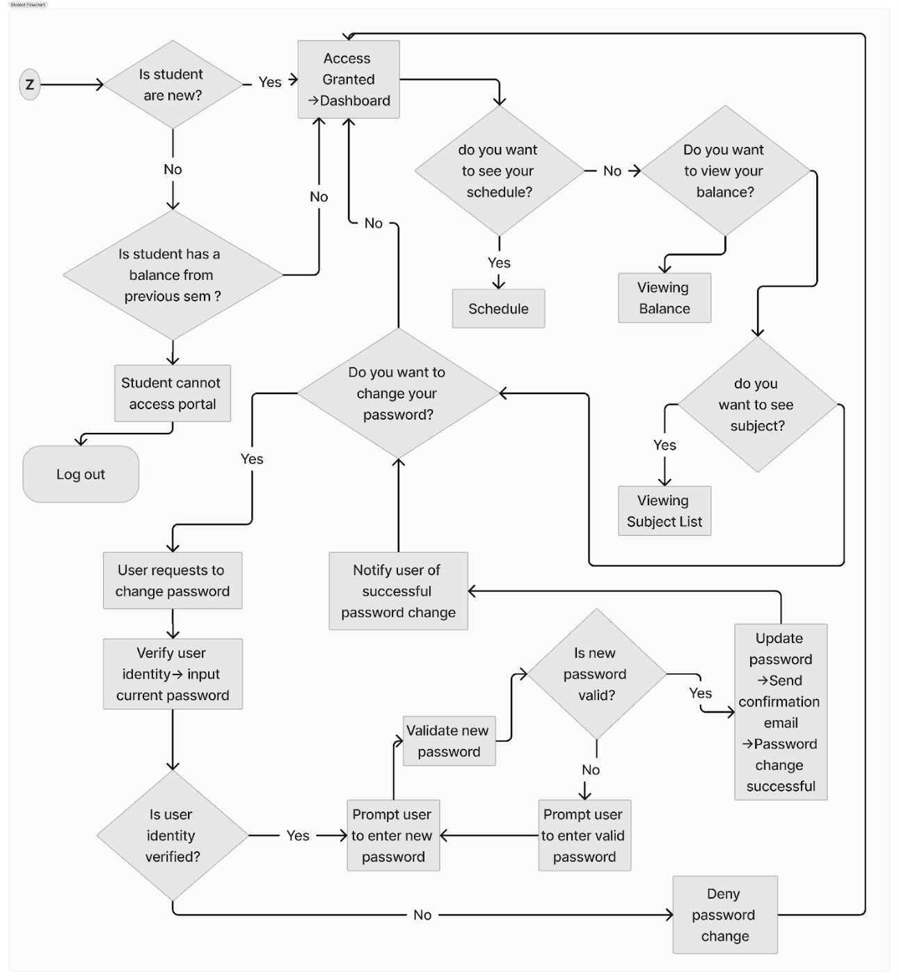

**Hardware and Software Resources**

**Hardware Requirements**

A fast operating system in a dedicated server is required for the hardware requirements of the School Portal System with access control algorithm for Westbridge Institute of Technology, Inc., Main Branch. This server will host the web-based and local server components. An Intel Xeon or AMD Ryzen multi-core processor with at least 8GB of RAM but possibly more depending on user volume and system load and lots of storage ideally SSDs for faster data access should be included in this server gear. Make that your network architecture that will include switches, routers, and internal and external cabling for connectivity. It will handle the combination of web-based and local server components. It will protect the system from unauthorized access and cyber threats. It will serve as security solutions like firewalls and intrusion detection and prevention systems which are important. Desktops, laptops, or mobile devices with web browsers will require the users to access the portal. These devices must meet minimal requirements for using web-based applications and ensuring consistent network connectivity both inside and outside the school's network.

**Software Requirements**Laravel 8.1 framework will serve as the foundational structure and will facilitate the creation of features such as user authentication, student registration, and communication channels among students, teachers, and administrators. Composer will manage the system's code components and will simplify the addition of new features and maintenance tasks. XAMPP, encompassing MySQL for data storage and Apache as the web server will provide the necessary environment to run the system locally and will handle the user requests and will manage databases. Visual Studio Code will enable developers to write and edit the system's code efficiently, offering tools like syntax highlighting and debugging functionalities. Together, these software components will streamline the development and maintenance of the school portal system, ensuring efficient access and management of school-related information for all stakeholders.PHP with the framework of Laravel 8.1, Composer, Xampp(MySQL, Apache), VScode.

**Marketing Strategy**

The researchers from Westbridge Institute of Technology Inc. Banlic Branch will recognize the importance of protecting the sensitive student data while still allowing easy access for authorized users. Our marketing strategy will use an access control algorithm to successfully accomplish these key objectives for school portal security. The researchers will emphasize the need of using personalized messages to protect student information from online threats and unauthorized access. By positioning our solution as a proactive measure to protect data integrity and maintain security within the academic community, the researchers will intend to gather the attention of school authorities. As the researchers develop educational materials that outline the benefits and operation of the access control algorithm, our strategy will base on instructional content via live demonstrations and interactive training sessions. School staff members will receive helpful guidance on configuring and managing access control settings. We will increase our visibility and reputation while disseminating information about data security in schools and advocating for best practices by collaborating with commercial partners and educational organizations.

**Software Evaluation**

      The data analysis, presentation, and interpretation of the system evaluation are included in this chapter. The purpose of this study is to evaluate the School portal security with access control algorithm for Senior high and College in Westbridge Institute of Technology Inc. Main branch. This section provides a summary of the data collected by survey questionnaires, which are further explained below.

**~** To be followed after the survey.

Table # The Overall Evaluation Result of the System

|  |  |  |
| --- | --- | --- |
| **Indicators** | **Mean** | **Verbal Interpretation** |
| **1.** Functionality |  |  |
| **2.** Content |  |  |
| **3.** Usability |  |  |
| **4.** Accessibility |  |  |
| **Weighted Mean** |  |  |

**Chapter V**

**Summary, Conclusion and Recommendation**

    This chapter discusses the implications of the results for the research challenge and how they add to the body of knowledge that exists in the field. This also outlines the study's limitations and provides conclusions and recommendations for more research based on the results.

**Summary**

    The school portal security with access control algorithm (SPS-ACA) system development study is centered on creating a safe and effective system for Westbridge Institute of Technology, Inc. (WITI). Secure data protection and efficient user access control are the goals of this system. The system minimizes the possibility of unauthorized usage and data loss by limiting portal access to only authorized users through the use of access control algorithms. Features provided by SPS-ACA are customized for administrators, teachers, and students, among other user roles. The SPS-ACA system is a comprehensive solution that addresses the efficiency and security requirements of WITI's educational ecosystem. The system prioritizes safe data protection and effective user access control, which not only improves the confidentiality and integrity of academic material but also creates a favorable learning environment that supports student success and academic achievement.

**Conclusions**

~after the survey

**Recommendations**

* Set a procedure for regular inspections to find any problems or potential improvements. This might involve asking users for feedback or performing regular assessments. You can make sure the system keeps serving users' demands efficiently by continuing to monitor its performance and remain alert. Establish a procedure for quickly applying updates and fixes to solve any problems found and maintain the system's functionality.
* Sustaining data security requires teaching users how to manage the school portal system properly. Provide clear guidance on using the system and putting best practices for data protection into reality by creating training materials that are easy to understand or by conducting sessions. Emphasize the value of choosing secure passwords, being aware of any security risks, and knowing how to use the system properly. In order to provide users with the knowledge and abilities necessary to protect their information and contribute to a secure online environment, support continuing learning and awareness-building activities.
* Make regular backups of critical data to several safe locations to reduce the possibility of losing it in the case of cyberattacks or system breakdowns. Strict access controls should also be implemented to restrict user privileges and guarantee that only people with permission can access particular data. You may improve the school portal system's overall security posture and provide users peace of mind about the security of their data by using these thorough data protection techniques.
* Gaining important insights and resources for enhancing data security measures within the school portal system can be achieved through collaboration with cybersecurity specialists, industry partners, and other educational institutions. Create connections for information sharing, coordinated research projects, or collaborations to enhance data security procedures and stop emerging risks.
* Establish a procedure for conducting routine user access reviews. Make sure that the permissions people have access to are in line with their current roles and responsibilities. Removing access from users who no longer need it to particular system resources is also important. You may lessen the possibility of unwanted access and stop possible security breaches brought on by hacked user accounts or overly generous access privileges by putting user access reviews into place.

**Appendices**

**Appendix A**

References

|  |  |
| --- | --- |
| [1] | y. A. Baheshm, , A. O. Aldhaibani. and S. AL-Shami, Online student portal, 2020. |
| [2] | K. Jacksi, F. H. Mohammed and S. Zebari, Student Attendance Management System, February 2018. |
| [3] | M. R. Raut, , T. P. Lokhande, K. D. Godbole , S. j. More and S. S. . Hatm, PCE Staff/Student Portal, 2019. |
| [4] | S. M. N. S. A. F. G. F. S. I. A. a. O. A. (S. S. T. Alatawi, A New Model for Enhancing Student Portal Usage in Saudi Arabia Universities,, 2021. |
| [5] | Rosmasari, Usability Study Of Student Academic Portal from a User’s Perspective,, 2019. |
| [6] | m. .HamdaniSantoso and S. Zulfikar, Web-Based New Student Admissions Application at PAB 8 SaentisPrivateHighSchool,NorthSumatraProvince, 2021. |
| [7] | D. A. D. F. P. Rizqi Fajar Pradipta, Proceedings of the 2nd Early Childhood anChildhood EducationProceedings of the 2nd Early Childhood and Primary Childhood Education, 2020. |
| [8] | W. v. E. a. C. G. R. B. J. Claessens, A review of the time management, 2019. |
| [9] | J. M. G. a. Z. D. Sayson, Automated Class Scheduling System, 2019. |
| [10] | K. J.Awadallah, K. J.Awadallah, 2018. |
| [11] | M. BLAU, Personnel Scheduling Management, TRANSPORTATION RESEARCH RECORD 1229 11 . |
| [12] | C. A. A. Adaobi, CLOUD COMPUTING IN HEALTH CARE: OPPORTUNITIES, ISSUES, AND APPLICATIONS: A SYSTEMATIC EVALUATION, vol. vol. 1, 2021. |
| [13] | V. . P. Karkute, S. N. Kamod, S. . D. Salve, and S. S. Shewale, CENTRALISED ACCESS SYSTEM FOR COLLEGE, 2023. |
| [14] | K. &. S. G. B. N. Vara Lakshmana Reddy, A Novel Approach on Online College Portal., 2019. |
| [15] | M. A. S. S. &. C. E. (Mac Iver, Widening the Portal: How Schools Can Help More Families Access and Use the Parent Portal to Support Student Success., 2020. |
| [16] | B. P. B. W. M. I. &. I. A. Bara, "Development of Online Academic Portal System Android Based on National University, 2020. |
| [17] | . B. j. Faritha, r. Revathi , m. Suganya and . M. N. Gladiss, IoT based Cloud Integrated Smart Classroom for smart and a sustainable Campus, 2020. |
| [18] | P. J. K. P. S. P. P. H. a. R. K. P. Jain, College Portal, 2020. |
| [19] | K. S. V. P. S. S. E. a. M. R. C. M. Babu, DESIGN OF ALUMNI PORTAL WITH DATA SECURITY, 2021. |
| [20] | S. S. a. E. C. M. A. Mac Iver, Widening the portal: How schools can help more families access and use the parent portal to, 2021. |
| [21] | . A. KHASSENEYEVA, A Case Study of the Conception of Curriculum Internationalisation in a Secondary School in Kazakhstan, 2018. |
| [22] | M. A. Peters, Encyclopedia of Teacher Education, 2022. |
| [23] | Secured Data Handling in Cloud-Based Pervasive Health Care System,, 2020. |
| [24] | J. A. C. a. R. G. Lumauag, Web-Based Information System Portal With SMS Support For Aklan State University-Kalibo Campus,, 2019. |
| [25] | R. A. M. L. R. A. J. N. S. &. C. J. ]Nuncio, An E-learning outreach program for public schools: Findings and lessons learned based on a pilot program in Makati City and Cabuyao City Laguna Philippines. Evaluation and Program Planning,, 2020. |
| [26] | F. E. De Guzman and B. D. Gerardo , Implementation of Enhanced Secure Hash Algorithm Towards a Secured Web, 2019. |
| [27] | M. D. Cruz, The Effectiveness of Information Systems in the Enrollment of State Universities and Colleges in Central Luzon Philippines: A Basis for Enhancement, 2019. |
| [28] | C. R. Alimboyong and ,. M. E. Bucjan2, Cloud computing adoption among state universities and colleges, 2019. |
| [29] | M. A. Laus, Admission Profiles as Predictors of, vol. Vol. 9 , Cebu, 2021. |
| [30] | M. A. Laus, Admission Profiles as Predictors of Academic Performance, 2021. |
| [31] | N. Mohammad, The Admission Policy Test and Effectiveness of Islamic Education in a Secular State, 2018. |
| [32] | B. G. S. Grepon, N. T. Baran, K. M. V. C. Gumonan, A. L. M. Martin and M. L. E. Lacsa, Designing and Implementing e-School Systems: An Information Systems Approach to School Management of a Community College in Northern Mindanao, Philippines, 2021. |
| [33] | J. A. Clarin, Web-Based Information System Portal With SMS Support For Aklan State University-Kalibo Campus, 2020. |
| [34] | R. F. Mayo, A. T. Villanueva, K. A. B. Ortiz, A. C. M. Reyes, J. J. S. Payad, R. L. Rodriguez and E. A. Serrano, Web-Based Enrollment System for Public Junior High School in the Philippines: A Case Study in the Province of Cavite Public Schools, 2022. |
| [35] | Z. A. Matos, Design and Implementation of an Online Enrolment System for Higher Education Institution amidst covid-19 Pandemic in Zamboanga Peninsula, Philippines, 2022. |
| [36] | K. R. C. Nuevo, Student's Evaluation of the Davao del Sur State College's Online Enrollment System, 2021. |
| [37] | M. J. A. Dacumos, Web-based Online Enrollment System for TNHS - Annex, 2022. |
| [38] | I. M. Morallo, LYCEUM OF THE PHILIPPINES UNIVERSITY – LAGUNA, vol. Vol. 4 , LPU-Laguna Journal of Multidisciplinary Research. |
| [39] | R. Lumauag, Online Research Portal, Iloilo: International Journal of Computer and Technology, 2018. |
| [40] | B. G. S. Grepon, Designing and Implementing e-School Systems: An Information Systems Approach to School Management of a Community College in Northern Mindanao, Philippines, 2021. |
| [41] | M. Helen B. Ancheta, THE NEW NORMAL IN EDUCATION: A CHALLENGE TO, vol. Volume 1, September 2020 ·. |
| [42] | K. D. Caratiquit, Web-based School Information and Publication System:, vol. Vol. I, Cagayan, July 5, 2021. |
| [43] | M. Dela Cruz, The Effectiveness of Information Systems in the Enrollment of State Universities and Colleges in Central Luzon Philippines: A Basis for Enhancement, 2019. |

**Appendix B**

**Gantt Chart**

|  |  |  |  |  |  |  |  |  |  |
| --- | --- | --- | --- | --- | --- | --- | --- | --- | --- |
| **Activities** | **Months** | | | | | | | | |
| **Sept**  **2023** | **Oct**  **2023** | **Nov**  **2023** | **Dec**  **2023** | **Jan**  **2024** | **Feb**  **2024** | **March**  **2024** | **April**  **2024** | **May**  **2024** |
| **Brainstorming**  **Rationale** |  |  |  |  |  |  |  |  |  |
| **Documentation**  **Chapter 1** |  |  |  |  |  |  |  |  |  |
| **Documentation**  **Chapter 2** |  |  |  |  |  |  |  |  |  |
| **Modeling plan** |  |  |  |  |  |  |  |  |  |
| **Documentation**  **Chapter 3** |  |  |  |  |  |  |  |  |  |
| **Title defense** |  |  |  |  |  |  |  |  |  |
| **Start coding**  **Prototype** |  |  |  |  |  |  |  |  |  |
| **Document revision**  **(Chapter 1-3)** |  |  |  |  |  |  |  |  |  |
| **Data Gathering**  **Interview** |  |  |  |  |  |  |  |  |  |
| **Dataflow** |  |  |  |  |  |  |  |  |  |
| **Documentation**  **Chapter 4** |  |  |  |  |  |  |  |  |  |
| **Program coding** |  |  |  |  |  |  |  |  |  |
| **Program testing**  **Deployment plan** |  |  |  |  |  |  |  |  |  |
| **System evaluation** |  |  |  |  |  |  |  |  |  |
| **Documentation**  **Chapter 5** |  |  |  |  |  |  |  |  |  |

**Appendix C**

**Questionnaire and Survey form**

|  |  |  |  |  |  |
| --- | --- | --- | --- | --- | --- |
| **School Portal Security with Access control Algorithm** | | | | | |
| **Criteria** | **5** | **4** | **3** | **2** | **1** |
| **Functionality** | **Excellent** | **Very Good** | **Good** | **Fair** | **Poor** |
| **1.** The necessary features are easily accessible from the homepage. |  |  |  |  |  |
| **2.** Users easily find and search within the system. |  |  |  |  |  |
| **3.** Clear instructions and prompts throughout the system to guide users. |  |  |  |  |  |
| **4.** Overall system functionality |  |  |  |  |  |
| **Average** |  |  |  |  |  |
| **Content** | **Excellent** | **Very Good** | **Good** | **Fair** | **Poor** |
| **1.** System meets all the specified requirements and features needed. |  |  |  |  |  |
| **2.** Content style of web based system. |  |  |  |  |  |
| **3.** Document format |  |  |  |  |  |
| **4.** General content comprehensiveness |  |  |  |  |  |
| **Average** |  |  |  |  |  |
| **Usability** | **Excellent** | **Very Good** | **Good** | **Fair** | **Poor** |
| **1.** Appropriate utilization of background images. |  |  |  |  |  |
| **2.** Color theme of the web based system. |  |  |  |  |  |
| **3.** Placing the button for pages. |  |  |  |  |  |
| **4.** General layout of user interface. |  |  |  |  |  |
| **Average** |  |  |  |  |  |
| **Accessibility** | **Excellent** | **Very Good** | **Good** | **Fair** | **Poor** |
| **1.** User accounts and passwords encryption protected. |  |  |  |  |  |
| **2.** Transaction history is accurate |  |  |  |  |  |
| **3.** Overall safeness/security using the system |  |  |  |  |  |
| **Average** |  |  |  |  |  |

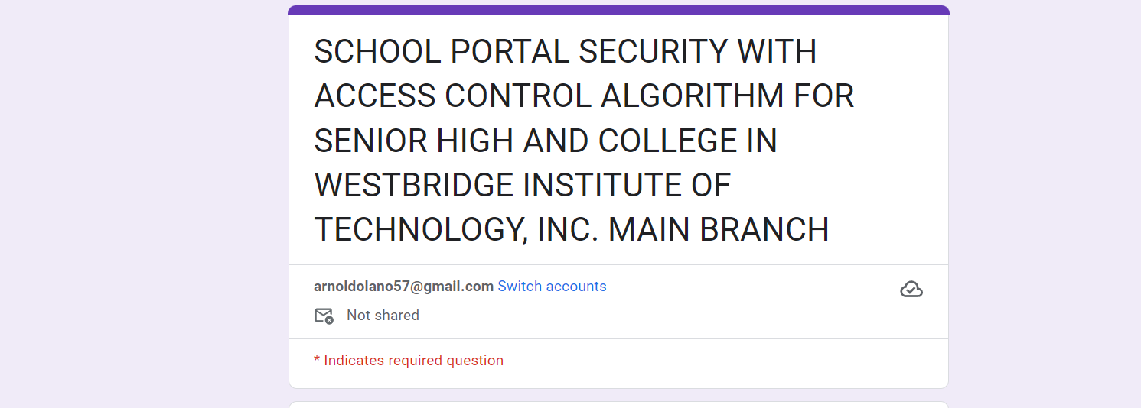

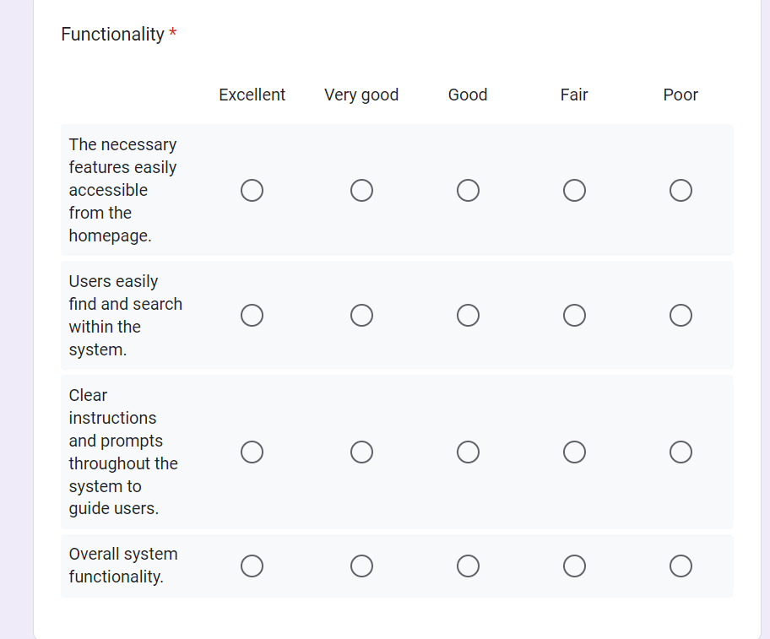

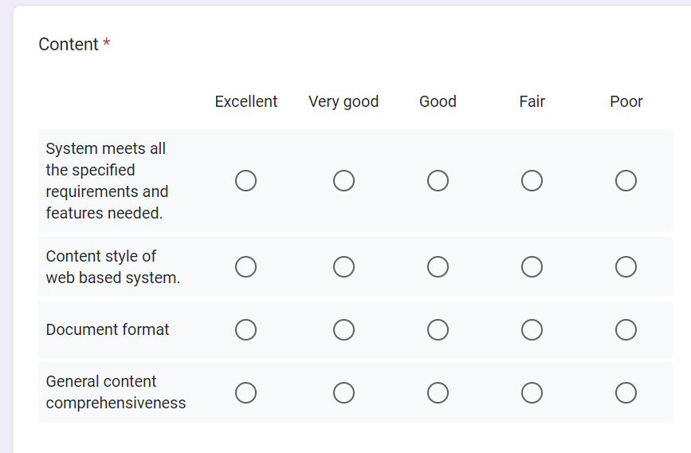

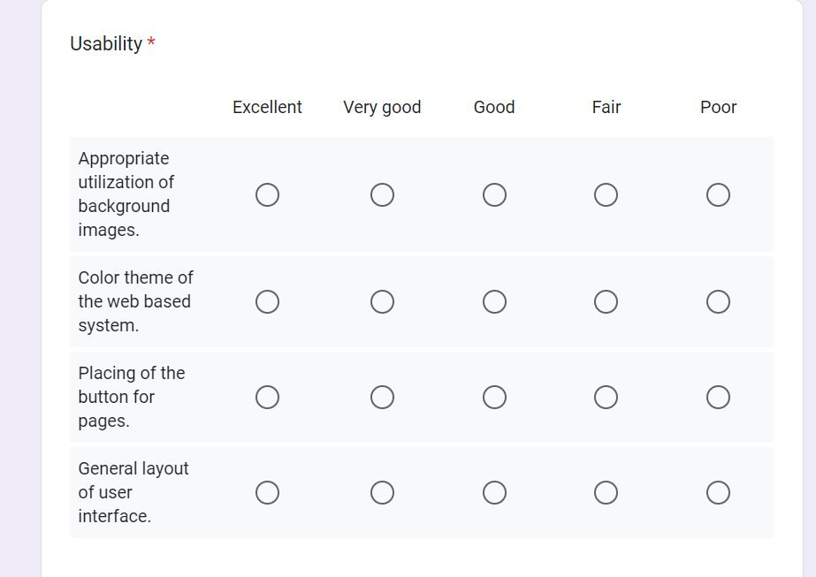

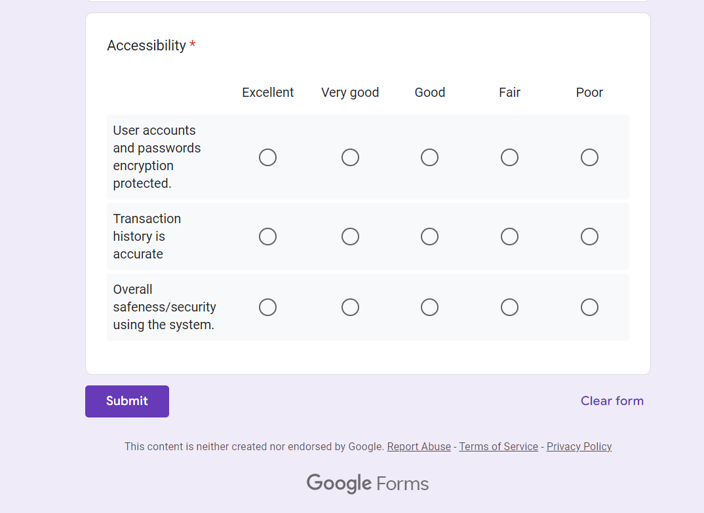

**Appendix D**

**Cost and Benefit Analysis**

**Costing**

|  |  |
| --- | --- |
| **Software programming Breakdown** | |
| **Items** | **Cost** |
| Domain | ₱600.00 / **₱1,500.00 (possibility)** |
| Hosting | ₱900.00 |
| **Total cost** | ₱1,500.00 / ₱2,400.00 |
| **Miscellaneous** | |
| **Research Professionals** | **Cost** |
| Thesis Adviser fee | ₱3,000.00 |
| Grammarian fee | ₱1,500.00 |
| Statistician |  |
| **Total cost** |  |

**Appendix E**

**Database design**

**Appendix F**

**Program Listing**

**Login code**

<?php

namespace App\Http\Controllers;

use Illuminate\Http\Request;

use Hash;

use Auth;

use App\Models\User;

use App\Mail\ForgotPasswordMail;

use Mail;

use Str;

class AuthController extends Controller

{

    //

    public function login()

    {

        //dd(Hash::make(12345));

       if(!empty(Auth::check())){

            if(Auth::user()->user_type == 1){

                return redirect('admin/dashboard');

            }

            elseif(Auth::user()->user_type == 2)

            {

                return redirect('teacher/dashboard');

            }

            elseif(Auth::user()->user_type == 3)

            {

                return redirect('student/dashboard');

            }

            elseif(Auth::user()->user_type == 4)

            {

                return redirect('parent/dashboard');

            }

        }

        return view('auth.login');

    }

    public function Authlogin(Request $request)

    {

        $remember = !empty($request->remember) ? true : false;

        if (Auth::attempt(['email'=> $request->email, 'password'=> $request->password], $remember))

        {

            if(Auth::user()->user_type == 1)

            {

                return redirect('admin/dashboard');

            }

            elseif(Auth::user()->user_type == 2)

            {

                return redirect('teacher/dashboard');

            }

            elseif(Auth::user()->user_type == 3)

            {

                return redirect('student/dashboard');

            }

            elseif(Auth::user()->user_type == 4)

            {

                return redirect('parent/dashboard');

            }

        }

        else{

            return redirect()->back()->with('error', 'Please enter correct email and password');

        }

    }

    public function forgotpassword()

    {

        return view('auth.forgot');

    }

    public function PostForgotPassword(Request $request)

    {

       // dd($request->all());

       $user = User::getEmailSingle($request->email);

       if (!empty($user)){

        $user->remember_token=Str::random(30);

        $user->save();

        Mail::to($user->email)->send(new ForgotPasswordMail($user));

        return redirect()->back()->with('success', "Please check your email and reset your password");

           }

       else{

        return redirect()->back()->with('error', "Email not found in the system.");

       }

    }

    public function reset($remember_token)

    {

       $user=  User::getTokenSingle($remember_token);

       if(!empty($user))

       {

            $data['user'] = $user;

            return view('auth.reset', $data);

       }

       else{

        abort(404);

       }

    }

    public function PostReset($token, request $request)

    {

         if ($request->password == $request->cpassword)

         {

        $user = User::getTokenSingle($remember_token);

        $user->password = Hash::make($request->password);

        $user->remember_token=Str::random(30);

        $user->saved();

        return redirect(url(''))->with('success', "Password successfully reset");

        }

        else

        {

            return redirect()->back()->with('error', "Password and confirm password does not match");

        }

    }

    public function logout()

    {

        Auth::logout();

        return redirect(url(''));

    }

}

**DashboardController.php**

<?php

namespace App\Http\Controllers;

use Illuminate\Http\Request;

use Auth;

use App\Models\User; // Make sure to import the User model

class DashboardController extends Controller

{

    public function dashboard()

    {

        $data['header_title'] = 'Dashboard';

        $adminCount = $this->getUserCount(1); // Assuming 1 is the user_type for admin

        $teacherCount = $this->getUserCount(3); // Assuming 2 is the user_type for teacher

        $studentCount = $this->getUserCount(2); // Assuming 3 is the user_type for student

        $userRegistrations = $this->getUserRegistrations();

        $data['adminCount'] = $adminCount;

        $data['teacherCount'] = $teacherCount;

        $data['studentCount'] = $studentCount;

        $data['userRegistrations'] = $userRegistrations;

        if (Auth::user()->user_type == 1) {

            return view('admin.dashboard', $data);

        } elseif (Auth::user()->user_type == 3) {

            return view('teacher.dashboard', $data);

        } elseif (Auth::user()->user_type == 2) {

            return view('student.dashboard', $data);

        }

    }

**StudentController.php**

<?php

namespace App\Http\Controllers;

use App\Http\Controllers\Controller;

use Illuminate\Http\Request;

use App\Models\User;

use App\Models\ClassModel;

use Hash;

use Auth;

use Str;

class StudentController extends Controller

{

    public function list(){

        $data['getRecord'] = User::getStudent();

        $data['header_title']='Student List';

        return view('admin.student.list',$data);

    }

    public function add(){

        $data['getClass']= ClassModel::getClass();

        $data['header_title']='Add New Student';

        return view('admin.student.add',$data);

    }

    public function insert(Request $request)

    {

request()->validate([

    'email' => 'required|email|unique:users',

    'weight' => 'max:10',

    'blood_group' => 'max:10',

    'mobile_number' => 'max: 15|min: 8',

    'admission_number' => 'max:50',

    'roll_number' => 'max: 50',

    'height' => 'max: 10',

        ]);

    $student = new User;  // Instantiate a new User model

    $student->name = trim($request->name);

    $student->last_name = trim($request->last_name);

    $student->admission_number = trim($request->admission_number);

    $student->roll_number = trim($request->roll_number);

    $student->class_id = trim($request->class_id);

    $student->gender = trim($request->gender);

    if(!empty($request->date_of_birth))

    {

    $student->date_of_birth = trim($request->date_of_birth);

    }

    if(!empty($request->file('profile_pic')))

    {

    $ext = $request->file('profile_pic')->getClientOriginalExtension();

    $file = $request->file('profile_pic');

    $randomStr = date('Ymdhis').Str::random(20);

    $filename = strtolower($randomStr).'.'.$ext;

    $file->move('upload/profile/', $filename);

    $student->profile_pic = $filename;

}

    $student->mobile_number = trim($request->mobile_number);

    if(!empty($request->admission_date))

    {

    $student->admission_date = trim($request->admission_date);

    }

    $student->blood_group = trim($request->blood_group);

    $student->height = trim($request->height);

    $student->weight = trim($request->weight);

    $student->status = trim($request->status); // Assuming status is a property of User model

    $student->email = trim($request->email);

    $student->password = Hash::make($request->password); // Hash the password before saving

    $student->user_type = 3;

    $student->save(); // Save the student record to the database

    return redirect('admin/student/list')->with('success', "Student Successfully Created");

    }

public function edit($id)

{

    $data['getRecord'] = User::getSingle($id);

    if(!empty($data['getRecord']))

    {

     $data['getClass'] = ClassModel::getClass();

        $data['header_title'] = "Edit Student";

        return view('admin.student.edit',$data);

    }

    else

    {

    abort (404);

    }

}

public function update($id, Request $request)

{

request()->validate([

'email' => 'required|email|unique:users,email,' .$id,

'weight' => 'max:10',

'blood_group' => 'max:10',

'mobile_number' => 'max: 15|min:8',

'admission_number' => 'max:50',

'roll_number' => 'max:50',

'caste' => 'max:50',

'religion' => 'max: 50',

'height' => 'max:10'

]);

$student = User::getSingle($id);  // Instantiate a new User model

$student->name = trim($request->name);

$student->last_name = trim($request->last_name);

$student->admission_number = trim($request->admission_number);

$student->roll_number = trim($request->roll_number);

$student->class_id = trim($request->class_id);

$student->gender = trim($request->gender);

if(!empty($request->date_of_birth))

{

$student->date_of_birth = trim($request->date_of_birth);

}

if(!empty($request->file('profile_pic')))

{

if(!empty($student->getProfile()))

{

    unlink('upload/profile/'.$student->profile_pic);

}

$ext =$request->file('profile_pic')->getClientOriginalExtension();

$file = $request->file('profile_pic');

$randomStr = date('Ymdhis'). Str::random(20);

$filename = strtolower($randomStr). '.'.$ext;

$file->move('upload/profile/', $filename);

$student->profile_pic = $filename;

}

$student->mobile_number = trim($request->mobile_number);

if(!empty($request->admission_date))

{

$student->admission_date = trim($request->admission_date);

}

$student->blood_group = trim($request->blood_group);

$student->height = trim($request->height);

$student->weight = trim($request->weight);

$student->status = trim($request->status); // Assuming status is a property of User model

$student->email = trim($request->email);

$student->password = Hash::make($request->password); // Hash the password before saving

$student->user_type = 3;

$student->save(); // Save the student record to the database

return redirect('admin/student/list')->with('success', "Student Successfully Updated");

}

public function delete($id)

{

$getRecord = User::getSingle($id);

if(!empty($getRecord))

{

$getRecord->is_delete = 1;

$getRecord->save();

return redirect()->back()->with('success', "Student Successfully Deleted");

}

else

{

abort (404);

}

}

}

**SubjectController.php**

<?php

namespace App\Http\Controllers;

use Illuminate\Http\Request;

use App\Models\SubjectModel;

use App\Models\ClassSubjectModel;

use Auth;

class SubjectController extends Controller

{

    public function list()

    {

        $data['getRecord'] = SubjectModel::getRecord();

        $data['header_title']="Subject List";

        return view('admin.subject.list',$data);

    }

    public function add()

    {

        $data['header_title']="Add Subject";

        return view('admin.subject.add',$data);

    }

public function insert(Request $request)

{

$save = new SubjectModel;

$save->name = trim($request->name);

$save->type = trim($request->type);

$save->status = trim($request->status);

$save->created_by = Auth::user()->id;

$save->save();

return redirect('admin/subject/list')->with('success', "Subject Sucessfully Created");

    }

public function edit($id)

{

$data['getRecord'] = SubjectModel::getSingle($id);

if(!empty($data['getRecord']))

{

$data['header_title'] = "Edit Subject";

return view('admin.subject.edit', $data);

}

else

{

  abort (404);

}

}

public function update($id, Request $request)

{

$save = SubjectModel::getSingle($id);

$save->name = trim($request->name);

 $save->type =trim($request->type);

 $save->status = trim($request->status);

 $save->save();

return redirect('admin/subject/list')->with('success', "Subject Sucessfully Updated");

}

public function delete($id)

{

$save = SubjectModel::getSingle($id);

 $save->is_delete = 1;

$save->save();

return redirect()->back()->with('success', "Subject Sucessfully Deleted");

}

public function MySubject()

{

    $data['getRecord'] = ClassSubjectModel::MySubject(Auth::user()->class_id);

    $data['header_title'] = "My Subject";

    return view('student.my_subject', $data);

}

}

**TeacherController.php**

<?php

namespace App\Http\Controllers;

use Illuminate\Http\Request;

use App\Models\User;

use Hash;

use Auth;

use Str;

class TeacherController extends Controller

{

    //

    public function list()

{

    $data['getRecord'] = User::getTeacher();

    $data['header_title'] = "Teacher List";

    return view('admin.teacher.list', $data);

}

public function add()

{

    $data['header_title'] = "Add New Teacher";

    return view('admin.teacher.add', $data);

}

public function insert(Request $request)

{

    // Validate the incoming request data

    $request->validate([

        'email' => 'required|email|unique:users',

        'mobile_number' => 'max:15|min:8',

        'marital_status' => 'max:50',

    ]);

    // Create a new User instance

    $teacher = new User;

    // Assign values from the request to the User instance

    $teacher->name = trim($request->name);

    $teacher->last_name = trim($request->last_name);

    $teacher->gender = trim($request->gender);

    if (!empty($request->date_of_birth)) {

        $teacher->date_of_birth = trim($request->date_of_birth);

    }

    if (!empty($request->admission_date)) {

        $teacher->admission_date = trim($request->admission_date);

    }

    // Handle profile picture upload

    if (!empty($request->file('profile_pic'))) {

        $ext = $request->file('profile_pic')->getClientOriginalExtension();

        $file = $request->file('profile_pic');

        $randomStr = date('Ymdhis') . Str::random(20);

        $filename = strtolower($randomStr) . '.' . $ext;

        $file->move('upload/profile/', $filename);

        $teacher->profile_pic = $filename;

    }

    $teacher->marital_status = trim($request->marital_status);

    $teacher->address = trim($request->address);

    $teacher->mobile_number = trim($request->mobile_number);

    $teacher->permanent_address = trim($request->permanent_address);

    $teacher->qualification = trim($request->qualification);

    $teacher->work_experience = trim($request->work_experience);

    $teacher->note = trim($request->note);

    $teacher->status = trim($request->status);

    $teacher->email = trim($request->email);

    $teacher->password = Hash::make($request->password);

    $teacher->user_type = 2;

    $teacher->save();

    return redirect('admin/teacher/list')->with('success', "Teacher Successfully Created");

}

    public function edit($id)

    {

        $data['getRecord'] = User::getSingle($id);

        if (!empty($data['getRecord'])) {

            $data['header_title'] = "Edit Teacher";

            return view('admin.teacher.edit', $data);

        } else {

            abort(404);

        }

    }

    public function update($id, Request $request)

    {

        request()->validate([

            'email' => 'required|email|unique:users,email,' . $id,

            'mobile_number' => 'max:15|min:8',

            'marital status' => 'max:50',

        ]);

        $teacher = User::getSingle($id);

        $teacher->name = trim($request->name);

        $teacher->last_name = trim($request->last_name);

        $teacher->gender = trim($request->gender);

        if (!empty($request->date_of_birth)) {

            $teacher->date_of_birth = trim($request->date_of_birth);

        }

        if (!empty($request->admission_date)) {

            $teacher->admission_date = trim($request->admission_date);

        }

        if (!empty($request->file('profile_pic'))) {

            $ext = $request->file('profile_pic')->getClientOriginalExtension();

            $file = $request->file('profile_pic');

            $randomStr = date('Ymdhis') . Str::random(20);

            $filename = strtolower($randomStr) . '.' . $ext;

            $file->move('upload/profile/', $filename);

            $teacher->profile_pic = $filename;

        }

        $teacher->marital_status = trim($request->marital_status);

        $teacher->address = trim($request->address);

        $teacher->mobile_number = trim($request->mobile_number);

        $teacher->permanent_address = trim($request->permanent_address);

        $teacher->qualification = trim($request->qualification);

        $teacher->work_experience = trim($request->work_experience);

        $teacher->note = trim($request->note);

        $teacher->status = trim($request->status);

        $teacher->email = trim($request->email);

        if (!empty($request->password)) {

            $teacher->password = Hash::make($request->password);

        }

        $teacher->save();

        return redirect('admin/teacher/list')->with('success', "Teacher Successfully Updated");

    }

        public function delete($id)

         {

        $getRecord = User::getSingle($id);

        if(!empty($getRecord)) {

            $getRecord->is_delete = 1;

            $getRecord->save();

            return redirect()->back()->with('success', "Teacher Successfully Deleted");

        } else {

            abort(404);

        }

}

    }

**UserController.php**

<?php

namespace App\Http\Controllers;

use Illuminate\Http\Request;

use App\Models\User;

use Auth;

use Hash;

class UserController extends Controller

{

    public function MyAccount()

    {

        $data['getRecord'] = User::getSingle(Auth::user()->id);

        $data['header_title'] = "My Account";

        if (Auth::user()->user_type == 1) {

            return view('admin.my_account', $data);

        } elseif (Auth::user()->user_type == 2) {

            return view('teacher.my_account', $data);

        } elseif (Auth::user()->user_type == 3) {

            return view('student.my_account', $data);

        }

    }

    public function UpdateMyAccountAdmin(Request $request)

{

    $id = Auth::user()->id;

    $request->validate([

        'name' => 'required|string|max:255',

        'email' => 'required|email|unique:users,email,' . $id

        // Add more validation rules as needed

    ]);

    $admin = User::getSingle($id);

    $admin->name = trim($request->name);

    $admin->email = trim($request->email);

    $admin->save();

    return redirect()->back()->with('success', "Account Successfully Updated");

}

    public function UpdateMyAccount(Request $request)

    {

        $id = Auth::user()->id;

        $request->validate([

            'email' => 'required|email|unique:users,email,' . $id,

            'mobile_number' => 'max:15|min:8',

            'marital_status' => 'max:50',

            // Add validation rules for other fields as needed

        ]);

        $teacher = User::getSingle($id);

        $teacher->name = trim($request->name);

        $teacher->last_name = trim($request->last_name);

        $teacher->gender = trim($request->gender);

        if (!empty($request->date_of_birth)) {

            $teacher->date_of_birth = trim($request->date_of_birth);

        }

        if (!empty($request->file('profile_pic'))) {

            $ext = $request->file('profile_pic')->getClientOriginalExtension();

            $file = $request->file('profile_pic');

            $randomStr = date('Ymdhis') . Str::random(20);

            $filename = strtolower($randomStr) . '.' . $ext;

            $file->move('upload/profile/', $filename);

            $teacher->profile_pic = $filename;

        }

        $teacher->profile_pic = $filename;

        $teacher->marital_status = trim($request->marital_status);

        $teacher->address = trim($request->address);

        $teacher->mobile_number = trim($request->mobile_number);

        $teacher->permanent_address = trim($request->permanent_address);

        $teacher->qualification = trim($request->qualification);

        $teacher->work_experience = trim($request->work_experience);

        $teacher->email = trim($request->email);

        $teacher->save();

        return redirect()->back()->with('success', "Account Successfully Updated");

    }

    public function UpdateMyAccountStudent(Request $request)

    {

        $id = Auth::user()->id;

        $request->validate([

            'email' => 'required|email|unique:users,email,' . $id,

            'weight' => 'max:10',

            'blood_group' => 'max:10',

            'mobile_number' => 'max:15|min:8',

            'height' => 'max:10',

        ]);

        $student = User::getSingle($id);

        $student->name = trim($request->name);

        $student->last_name = trim($request->last_name);

        $student->gender = trim($request->gender);

        if (!empty($request->date_of_birth)) {

            $student->date_of_birth = trim($request->date_of_birth);

        }

        if (!empty($request->file('profile_pic'))) {

            if (!empty($student->getProfile())) {

                $ext = $request->file('profile_pic')->getClientOriginalExtension();

                unlink('upload/profile/' . $student->profile_pic);

                $randomStr = date('Ymdhis') . Str::random(20);

                $filename = strtolower($randomStr) . '.' . $ext;

                $file->move('upload/profile/', $filename);

                $student->profile_pic = $filename;

            }

        }

        $student->mobile_number = trim($request->mobile_number);

        $student->blood_group = trim($request->blood_group);

        $student->height = trim($request->height);

        $student->weight = trim($request->weight);

        $student->email = trim($request->email);

        $student->save();

        return redirect()->back()->with('success', "Account Successfully Updated");

    }

    public function change_password()

    {

        $data['header_title'] = "Change Password";

        return view('profile.change_password', $data);

    }

public function update_change_password (Request $request)

{

$user = User::getSingle (Auth::user()->id);

if(Hash::check($request->old_password, $user->password))

{

    $user->password = Hash::make($request->new_password);

     $user->save();

     return redirect()->back()->with('success', "Password successfully updated");

}

else

{

return redirect()->back()->with('error', "Old Password is not Correct");

}

}

}

**Appendix G**

**Approval Letter**

**Appendix H**

**Certificates**

**Appendix I**

**Curriculum Vitae**

